System design

5.1 SYSTEM ARCHITECTURE DESIGN:
5.1.1 E-R Diagram:
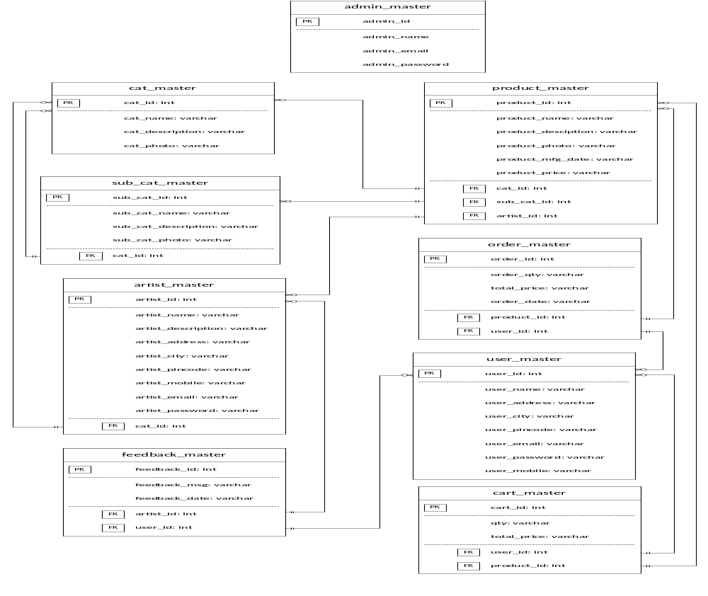
Figure 5.1: E – R Diagram
5.1.2 Use case Diagram:
- Registered User:

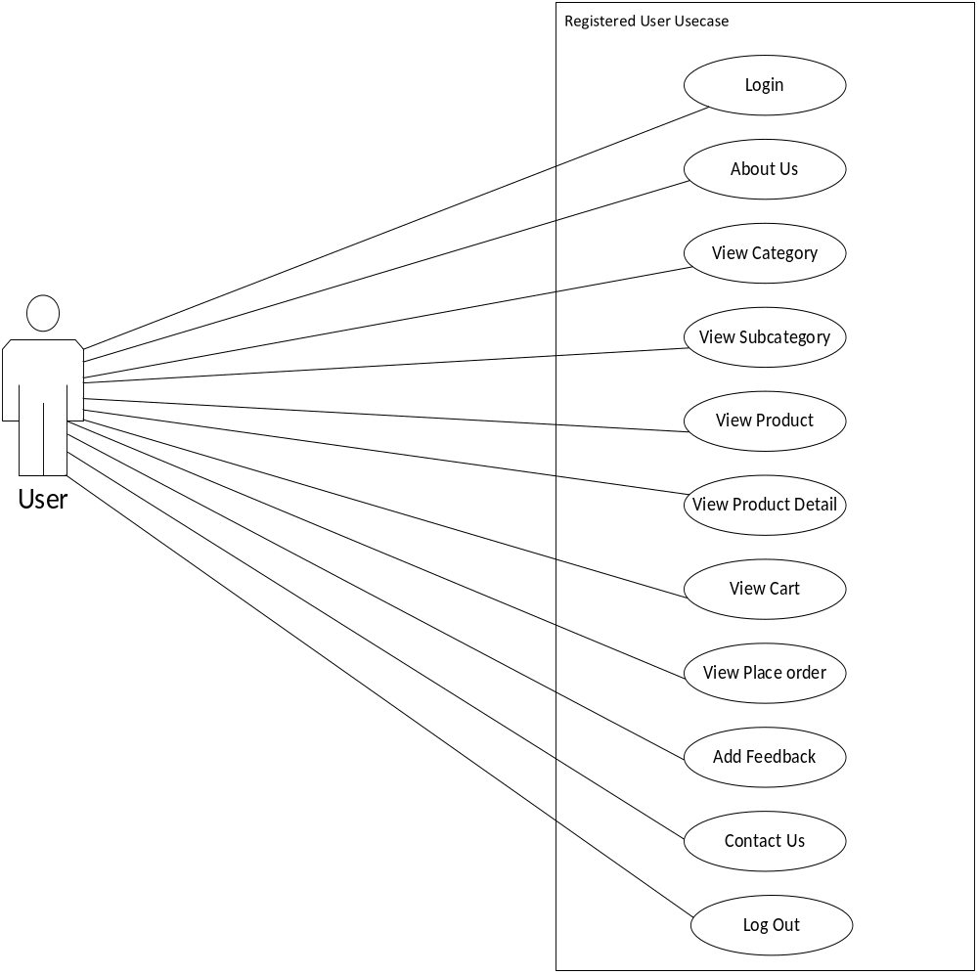

Figure 5.2: Use case Diagram for Register

- Admin:

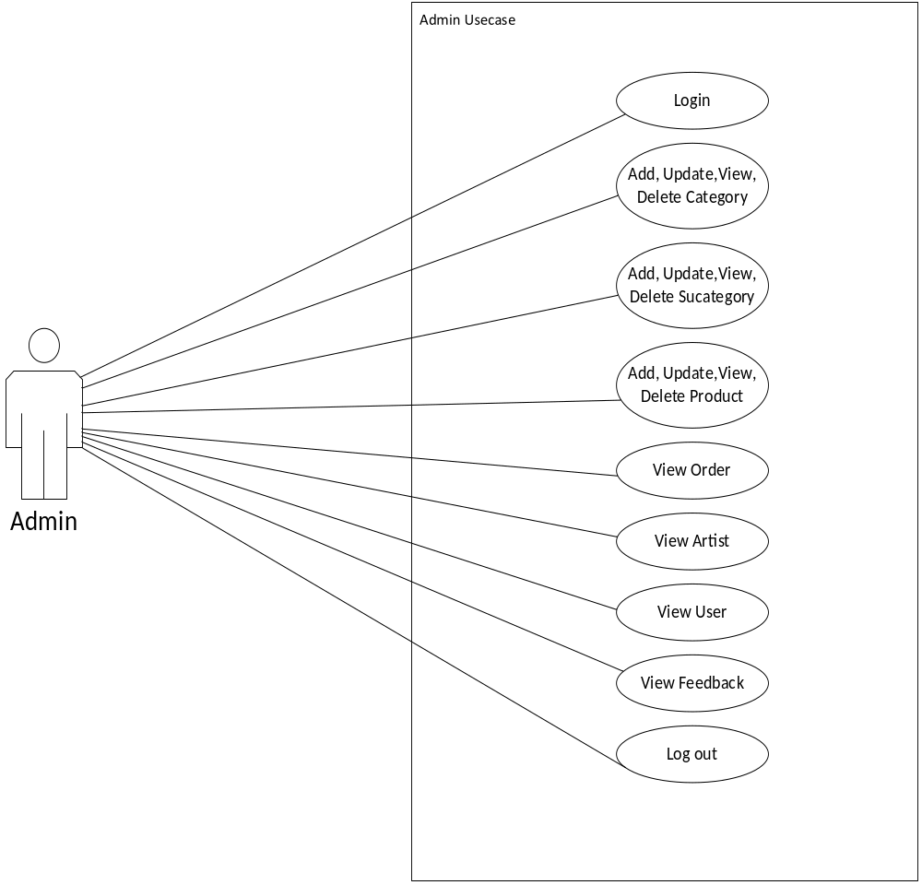
Figure 5.3: Use case Diagram for admin

- Guest User:

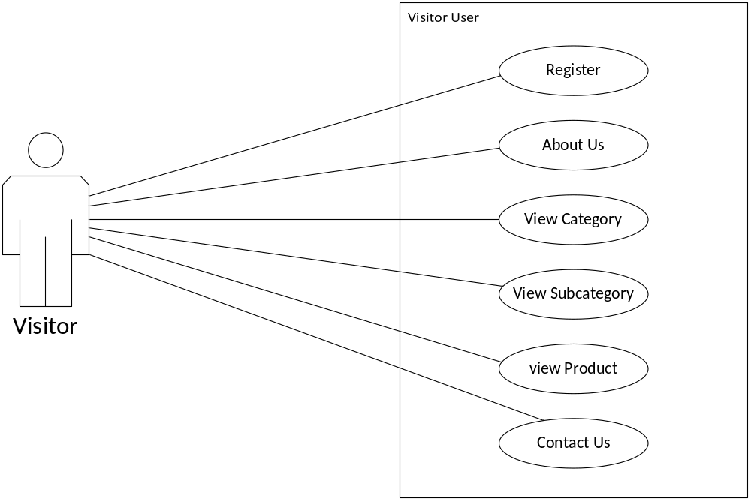

Figure 5.4: Use case Diagram for Guest User

5.1.3 Data Flow Diagram:
          - Context Diagram:

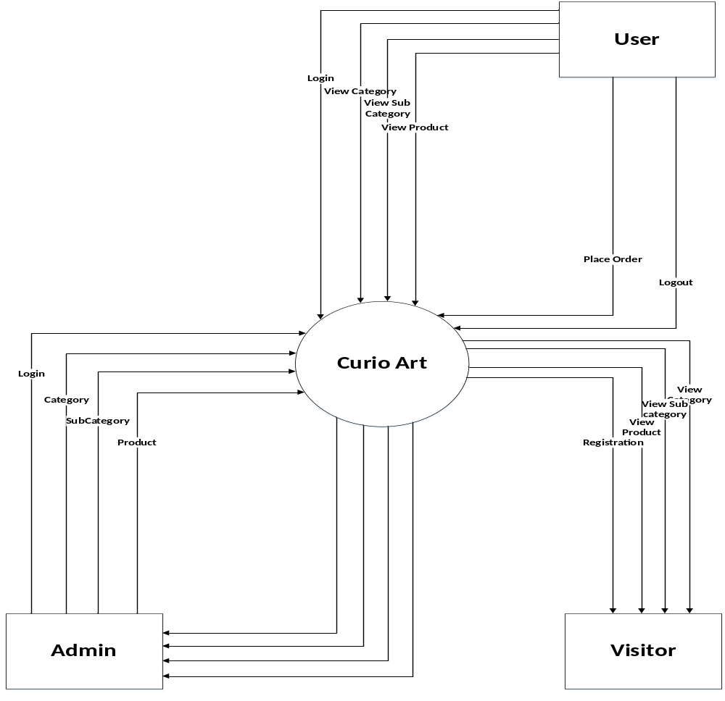
Figure 5.5: Context Diagram

b) 1evel 1 Data Flow Diagram
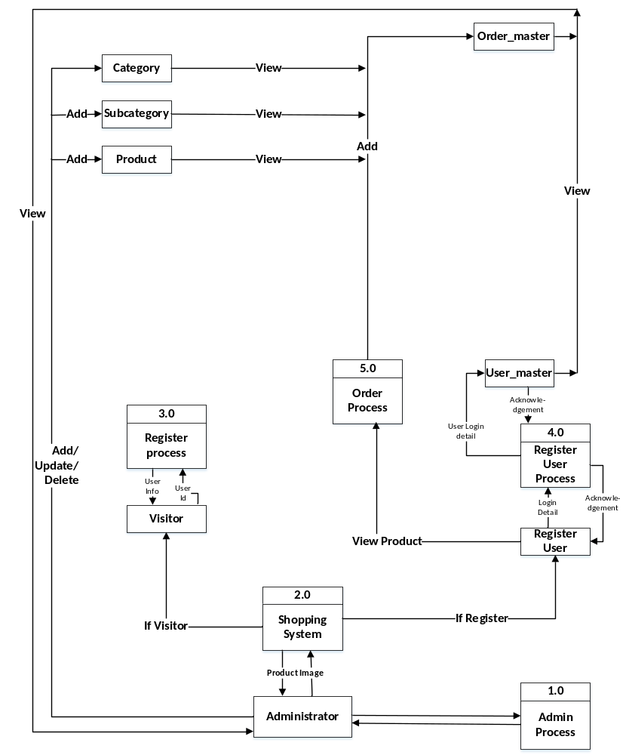
figure 5.6: 1 - Level Data Flow Diagram
c) Activity Diagram :
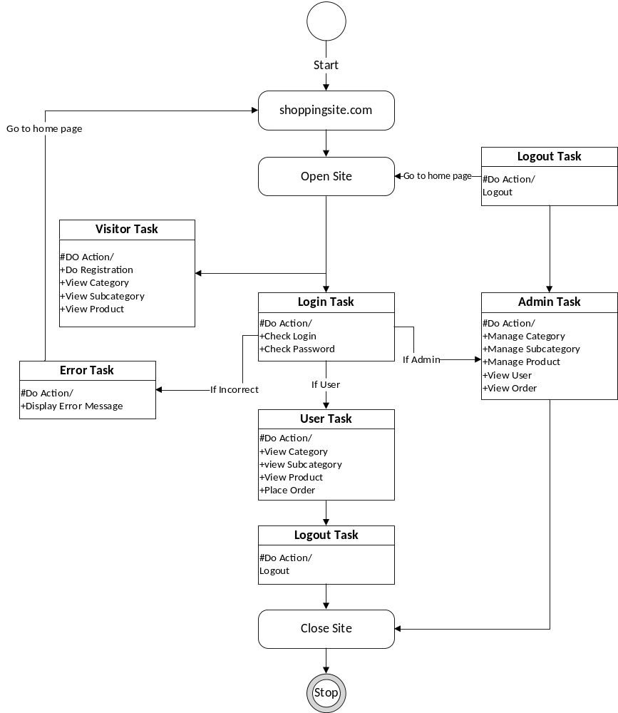

Figure 5.7: Activity Diagram

5.2 DATA DICTIONARY

Table Name: Admin_login
Description: This table contains the Admin Details.
SR. No | FIELD NAME | DATA TYPE | SIZE | CONSTRAINT | DETAIL
1 | Adm_id | int | 5 | Primary Key | Primary Key
2 | Adm_name | Varchar | 25 | - | -
3 | Admin_email | Varchar | 25 | - | -
4 | Admin_password | Varchar | 25 | - | -

Table Name: cat_master
Description: This table contains details about different category.
SR. No | FIELD NAME | DATA TYPE | SIZE | CONSTRAINT | DESCRIPTION
1 | Cat_id | Int | 5 | Primary Key | Primary key
2 | Cat_name | varchar | 25 | - | -
3 | Cat_description | Varchar | 250 | - | -
4 | Cat_photo | Varchar | 100 | - | -

Table Name: user registration
Description: This table contains the information about user registration.
SR. No | FIELD NAME | DATA TYPE | SIZE | CONSTRAIANT | DESCRIPTION
1 | User_id | Int | 5 | Primary Key | Primary key
2 | User_name | varchar | 25 | - | -
3 | User_address | Varchar | 100 | - | -
4 | User_city | Varchar | 50 | - | -
5 | User_pincode | Varchar | 20 | - | -
6 | User_email | Varchar | 20 | - | -
8 | User_password | Varchar | 25 | - | -
8 | User_mobileno | Varchar | 25 | - | -

Table Name: sub_cat_master
Description: This table contains information about sub category.
SR. No | FIELD NAME | DATA TYPE | SIZE | CONSTRAINTS | DESCRIPTION
1 | Sub_cat_id | Int | 5 | Primary Key | Primary key
2 | Sub_cat_name | varchar | 25 | - | -
3 | Sub_cat_description | Varchar | 500 | - | -
4 | Cat_id | Int | 5 | Reference Key | -

Table Name: product_master
Description: This table contains details about product.
SR. No | FIELD NAME | DATA TYPE | SIZE | CONSTRAINT | DESCRIPTION
1 | Product_id | Int | 5 | Primary key | Primary key
2 | Product_name | Varchar | 100 | - | -
3 | Product_description | Varchar | 200 | - | -
4 | Product_photo | Varchar | 100 | - | -
5 | Product_mfg_date | Varchar | 25 | - | -
6 | Product_price | Varchar | 10
7 | Cat_id | Int | 15 | Reference Key | -
8 | Sub_cat_id | Int | 15 | Reference Key | -
9 | Artist_id | Int | 15 | Reference Key | -

Table Name: Order_master
Description: This table contains details about order.
SR. No | FIELD NAME | DATA TYPE | SIZE | CONSTRAINT | DESCRIPTION
1 | Order_id | Int | 5 | Primary key | Primary key
2 | Order_qty | Varchar | 50 | - | -
3 | Total_price | Varchar | 10 | - | -
4 | Order_date | Varchar | 15 | - | -
5 | User_id | Int | 15 | Reference Key | -
6 | Product_id | Int | 15 | Reference Key | -
Table Name: artist registration
Description: This table contains the information about user registration.
SR. No | FIELD NAME | DATA TYPE | SIZE | CONSTRAIANT | DESCRIPTION
1 | Artist_id | Int | 5 | Primary Key | Primary key
2 | Artist_name | varchar | 25 | - | -
3 | Artist_description | Varchar | 200 | - | -
4 | Artist_address | Varchar | 100 | - | -
5 | Artist_city | Varchar | 50 | - | -
6 | Artist_pincode | Varchar | 20 | - | -
7 | Artist_email | Varchar | 20 | - | -
8 | Artist_password | Varchar | 25 | - | -
9 | Artist_mobileno | Varchar | 25 | - | -
10 | Cat_id | Int | 15 | Reference Key | -
Table Name: Feedback_master
Description: This table contains details about order.
SR. No | FIELD NAME | DATA TYPE | SIZE | CONSTRAINT | DESCRIPTION
1 | Feedback_id | Int | 15 | Primary key | Primary key
2 | Feedback_msg | Varchar | 250 | - | -
3 | Feedback_date | Varchar | 50 | - | -
4 | Artist_id | Int | 15 | Reference Key | -
Table Name: Cart_master
Description: This table contains details about order.
SR. No | FIELD NAME | DATA TYPE | SIZE | CONSTRAINT | DESCRIPTION
1 | Cart_id | Int | 5 | Primary key | Primary key
2 | qty | Varchar | 50 | - | -
3 | Total_price | Varchar | 10 | - | -
4 | Product_id | Int | 15 | Reference Key | -
5 | User_id | Int | 15 | Reference Key | -

5.3 Sample Code
<?php
include("connect.php");
$user_name=$_POST["user_name"];
$user_address=$_POST["user_address"];
$user_city=$_POST["user_city"];
$user_pincode=$_POST["user_pincode"];
$user_email=$_POST["user_email"];
$user_password=$_POST["user_password"];
$user_mobile=$_POST["user_mobile"];
$q="insert into user_master(user_name,user_address,user_city,user_pincode,user_email,user_password,user_mobile)values('$user_name','$user_address','$user_city','$user_pincode','$user_email','$user_password','$user_mobile')";
$i=mysqli_query($cn,$q);
if($i==1)
{ echo"Inserted..."; }
else
{
echo"Not Inserted...";
}
?>

5.4 SCREENSHOT
VISITOR
1) Home Page
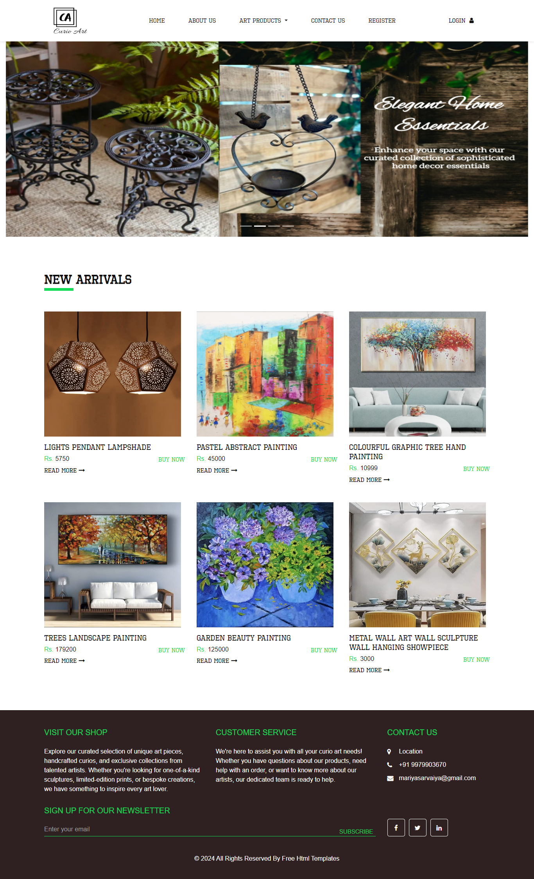
This is a visitor side home page.
2) About Us
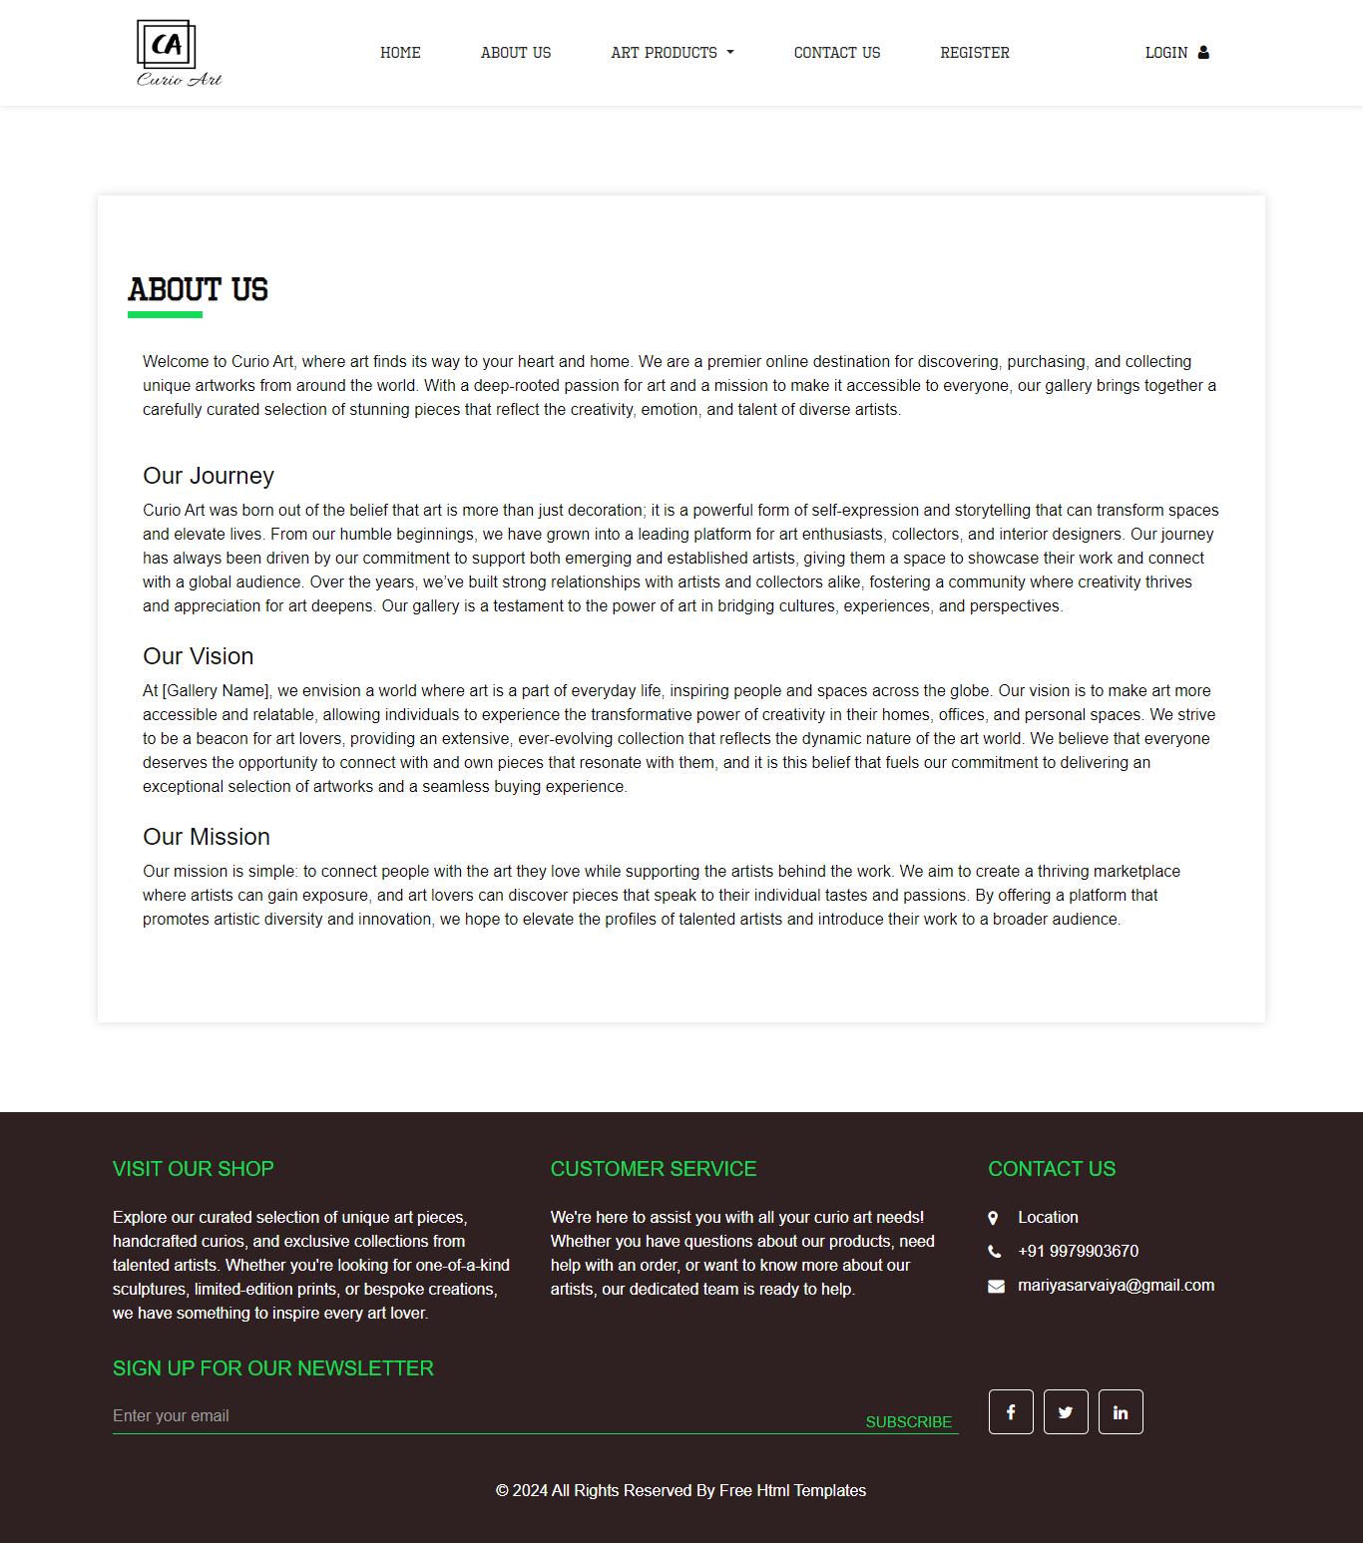
This page is a show detail of our shop.

3) Category
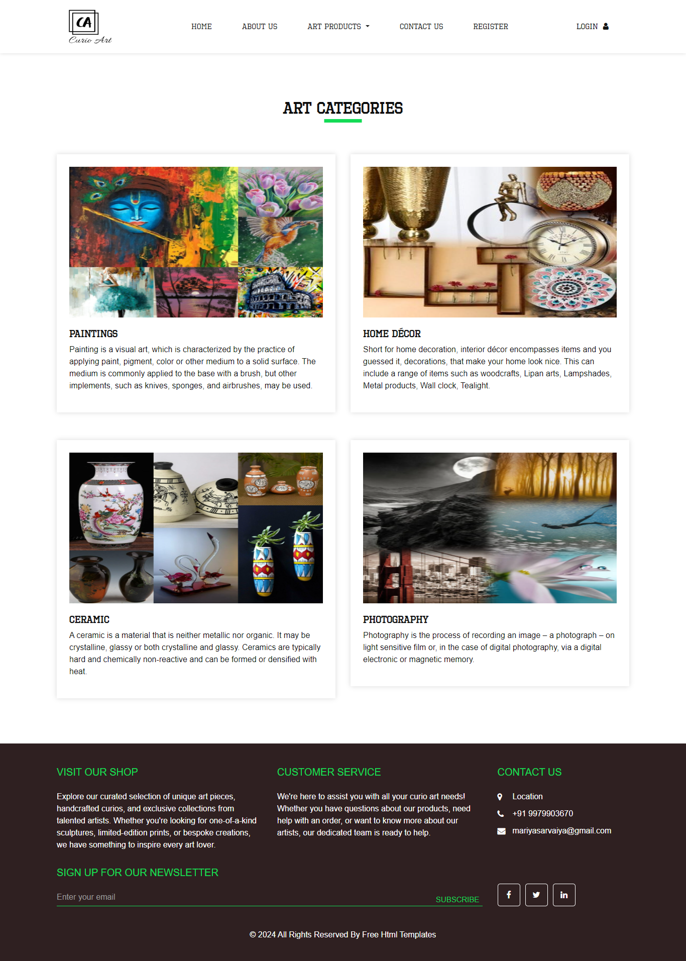
This page is a show the visitor side category.
4) View Sub Category
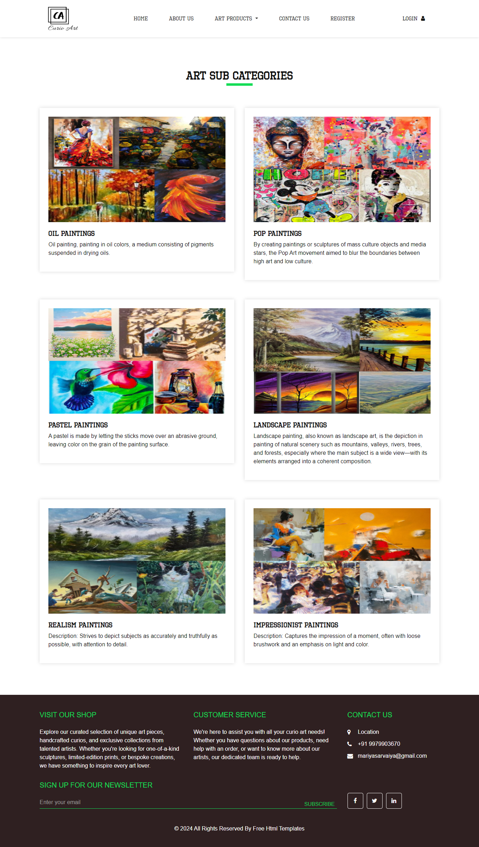
This page is a show the visitor side subcategory.
5) View Product
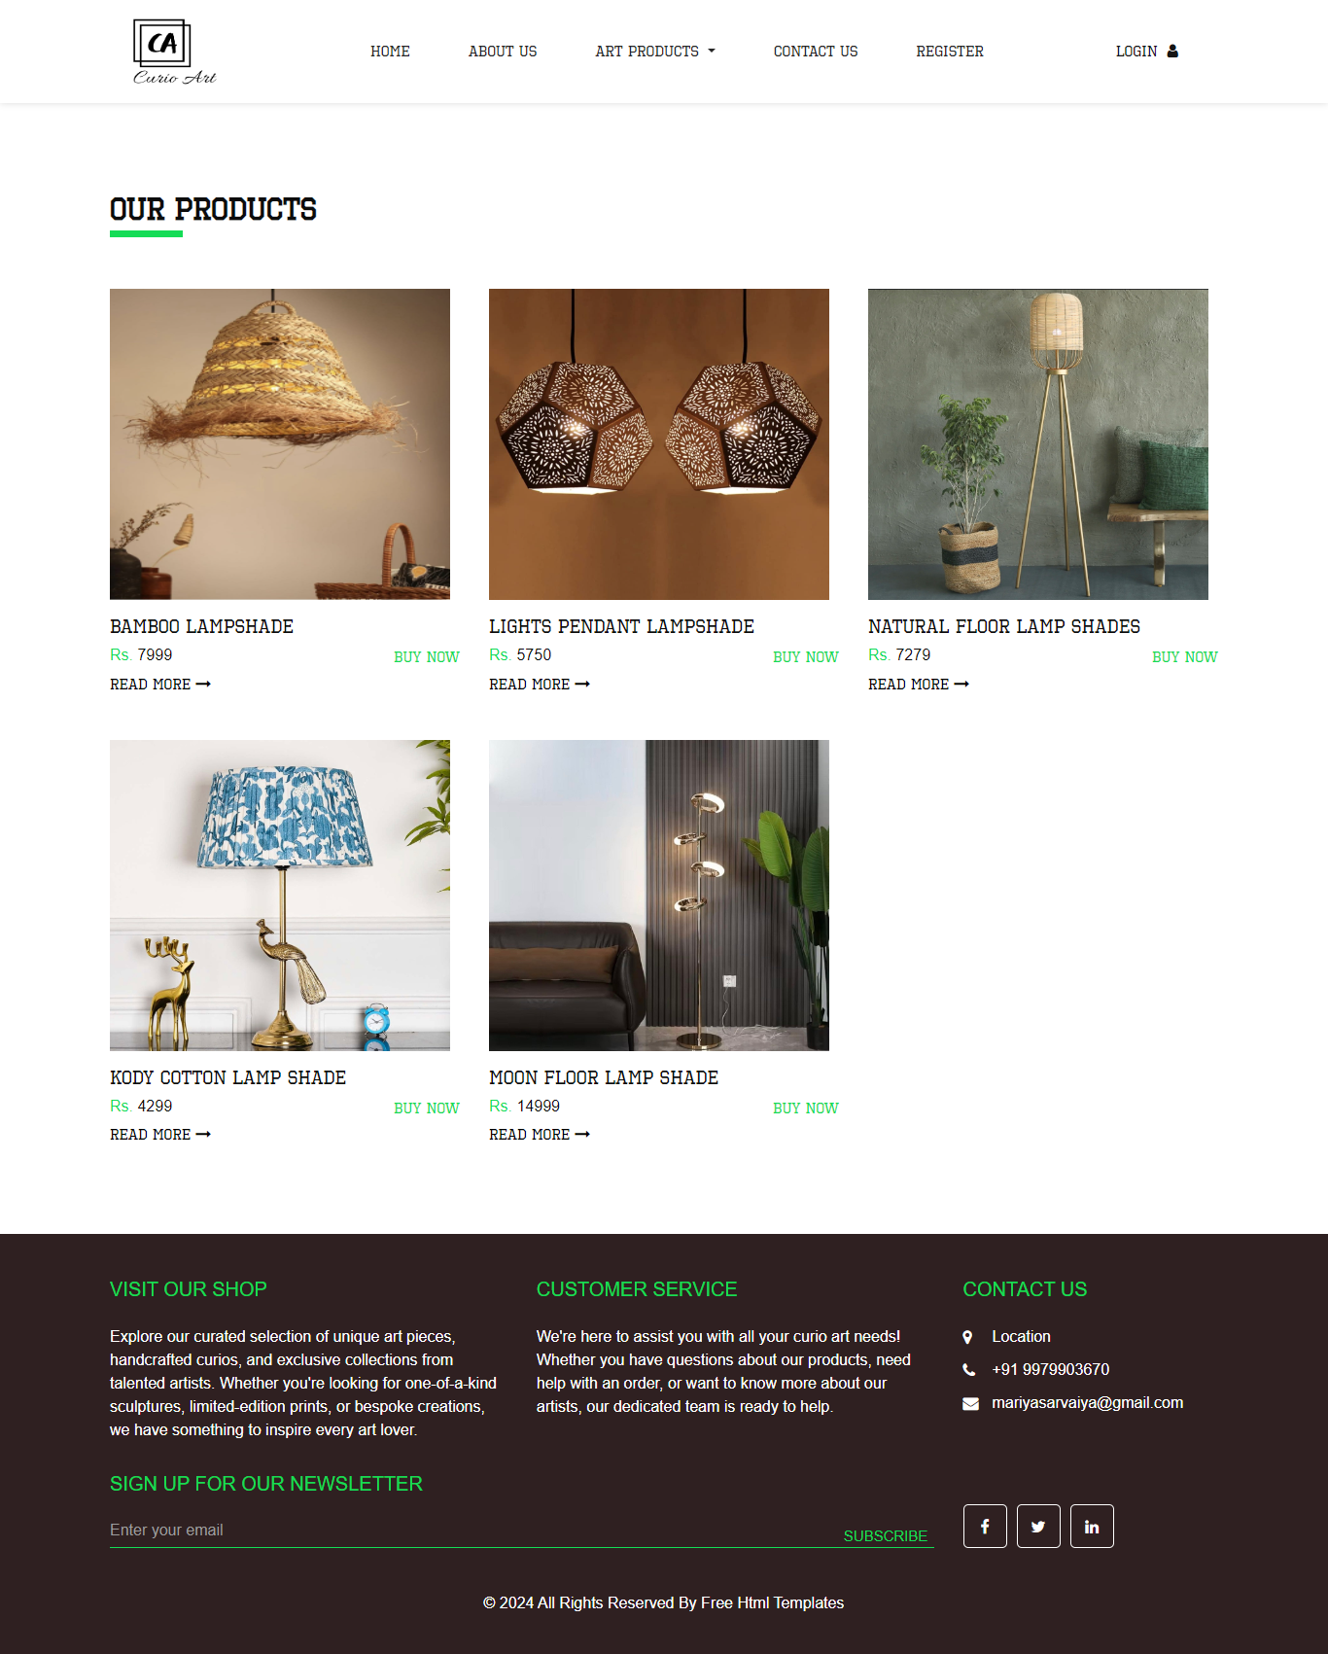
This page is a show the visitor side product.
6) View Product Detail
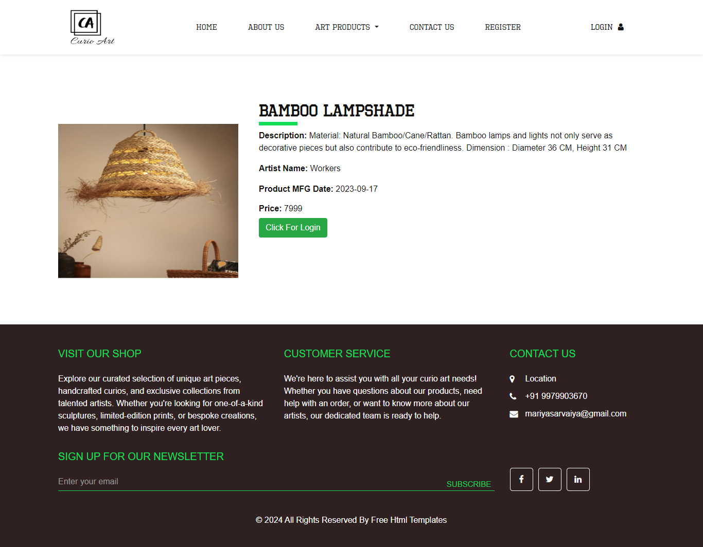
This page is a show the visitor side product detail.

7)View Contact Us
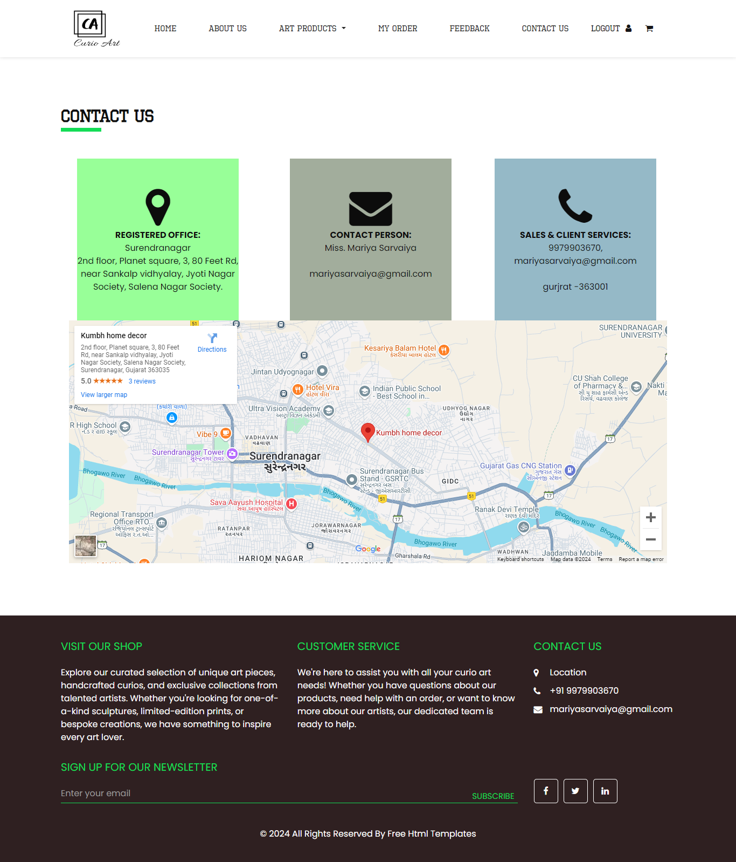
For any enquiry to contact us.
8)Registration Page
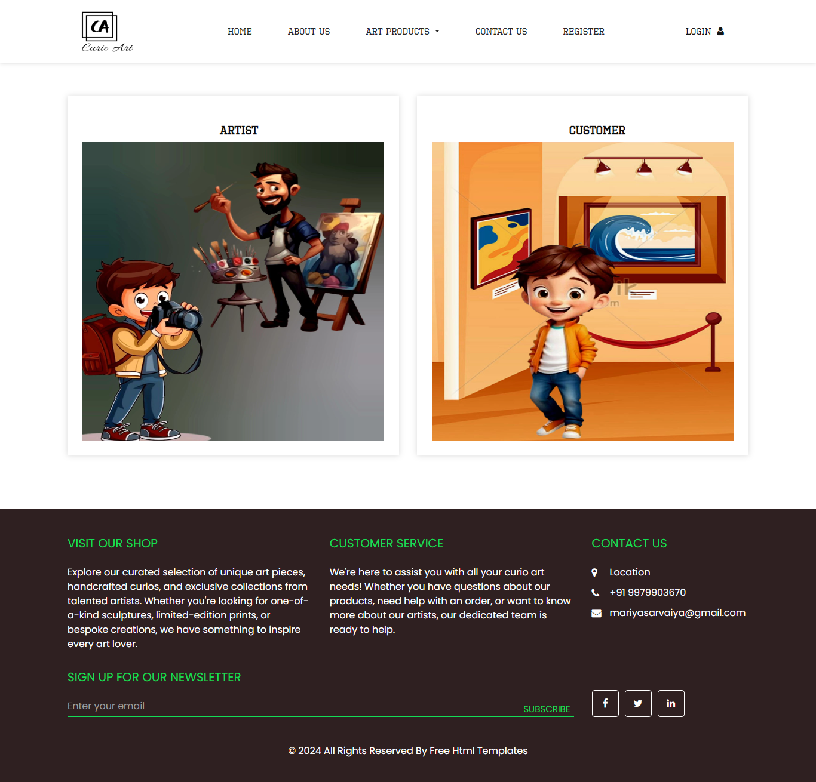
This page is show the registration page for the visitor.

10) Artist Registration
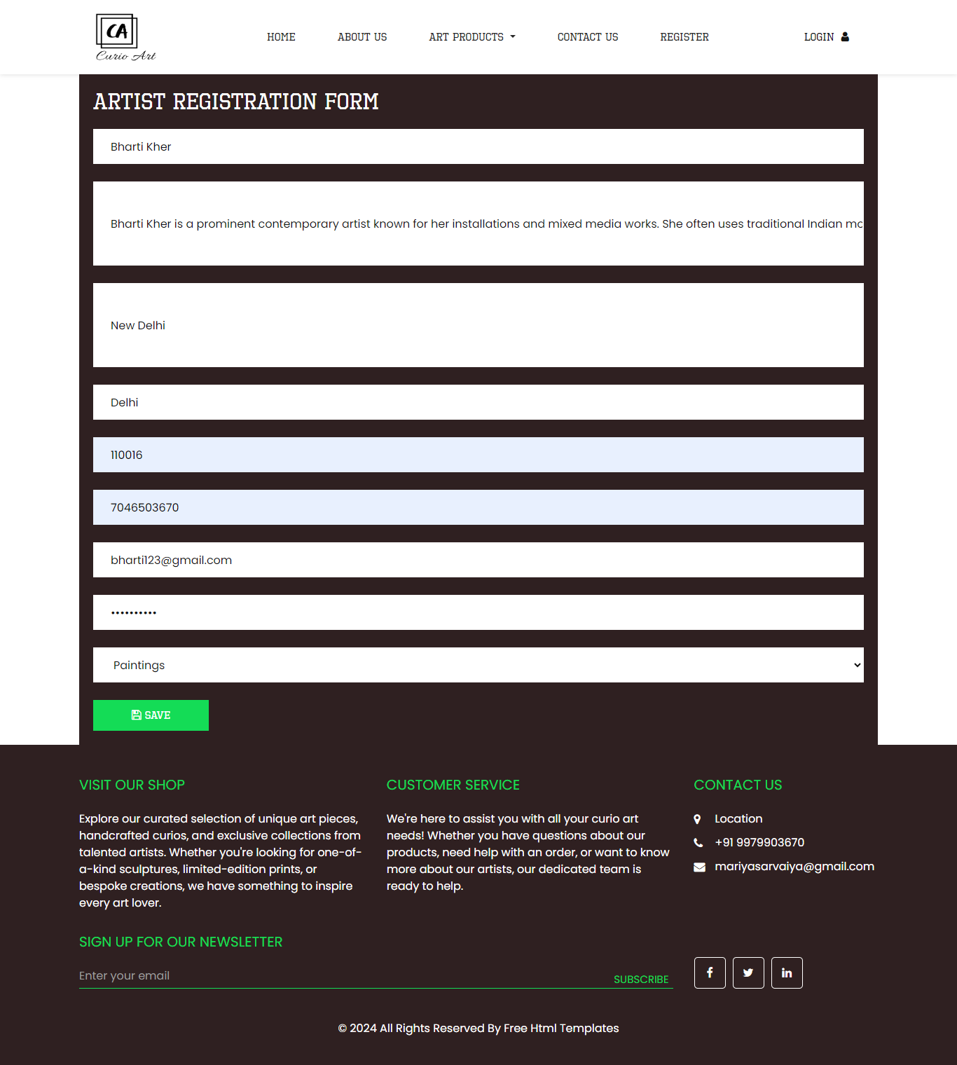
This page is show the artist registration form for the visitor.

11) User Registration
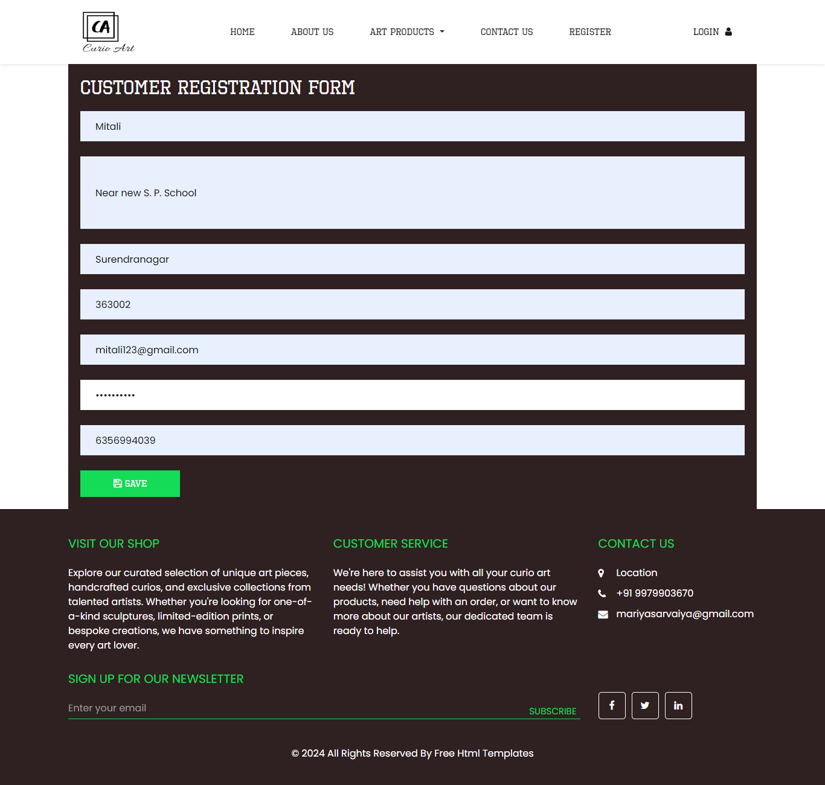
This page is show the user registration form for the visitor.

ADMINISTRATOR
1)Admin Login
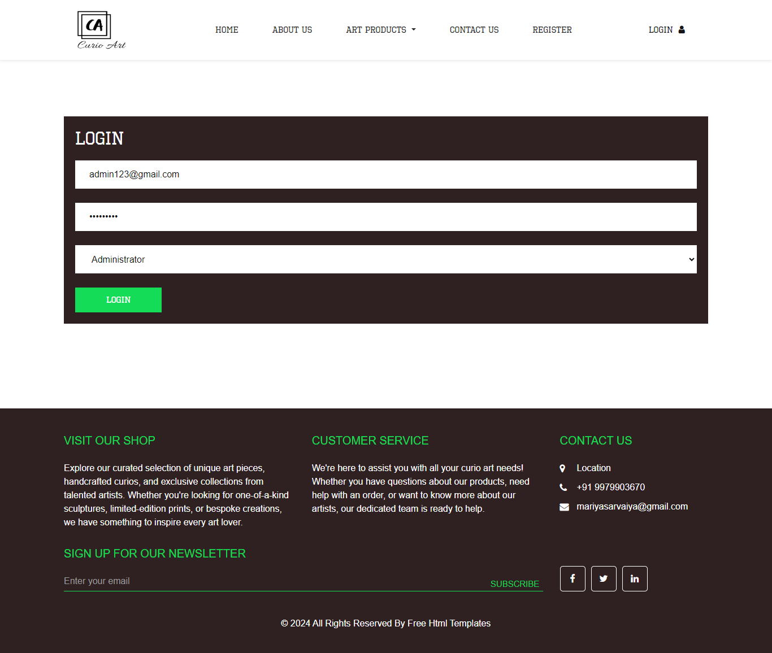
This page is for a admin login.

2)Admin Home
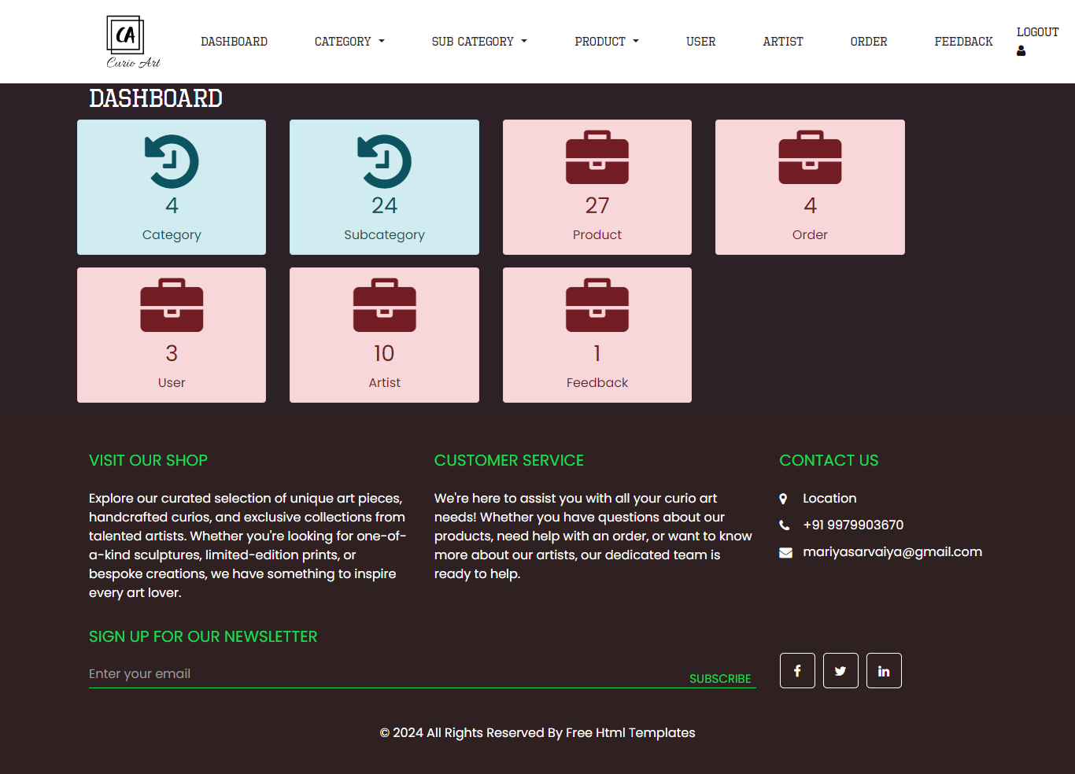
This is a admin side home page.

3)Add Category
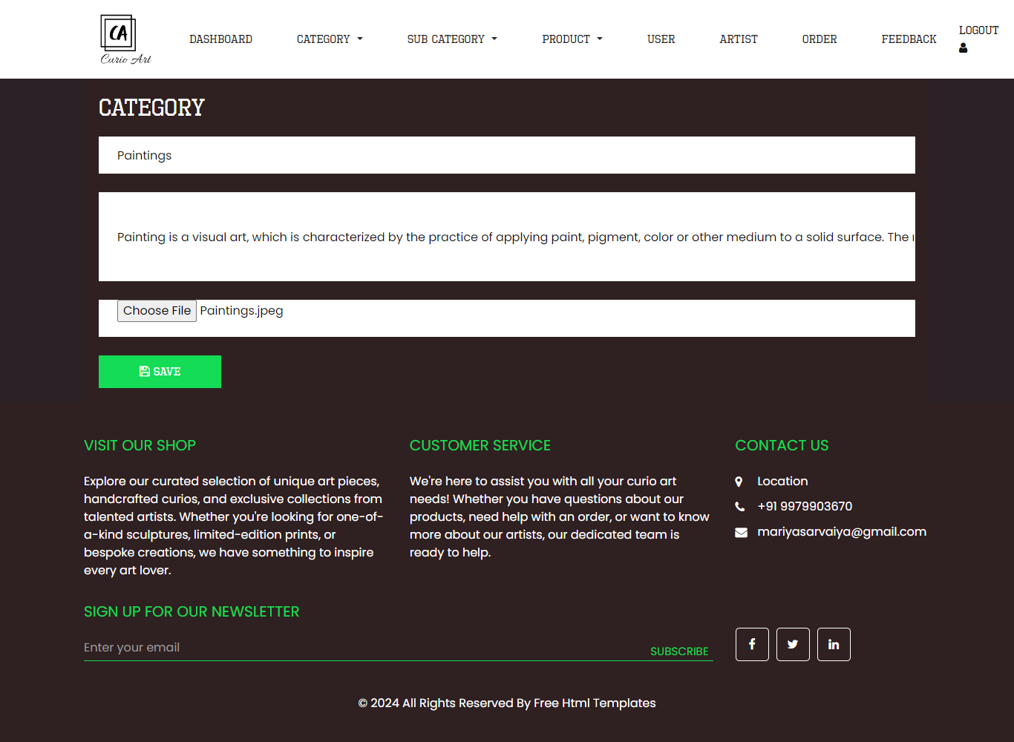
This is a for add category page.

4)View Category
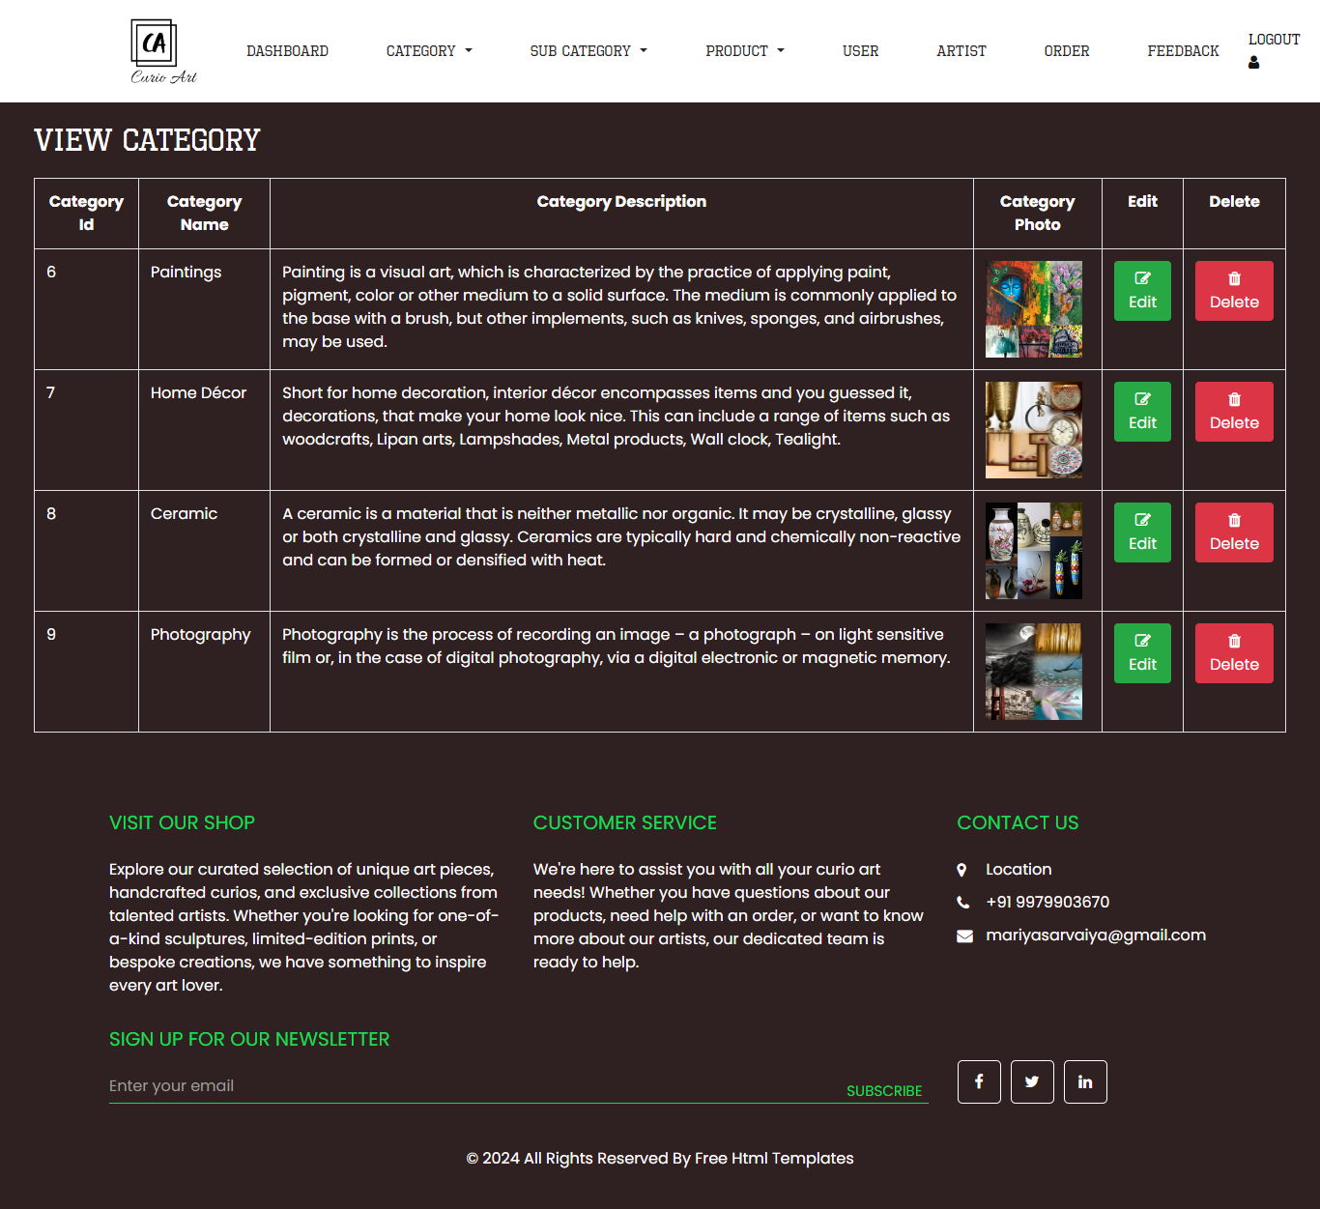
This is a for view category page.

5)Edit Category
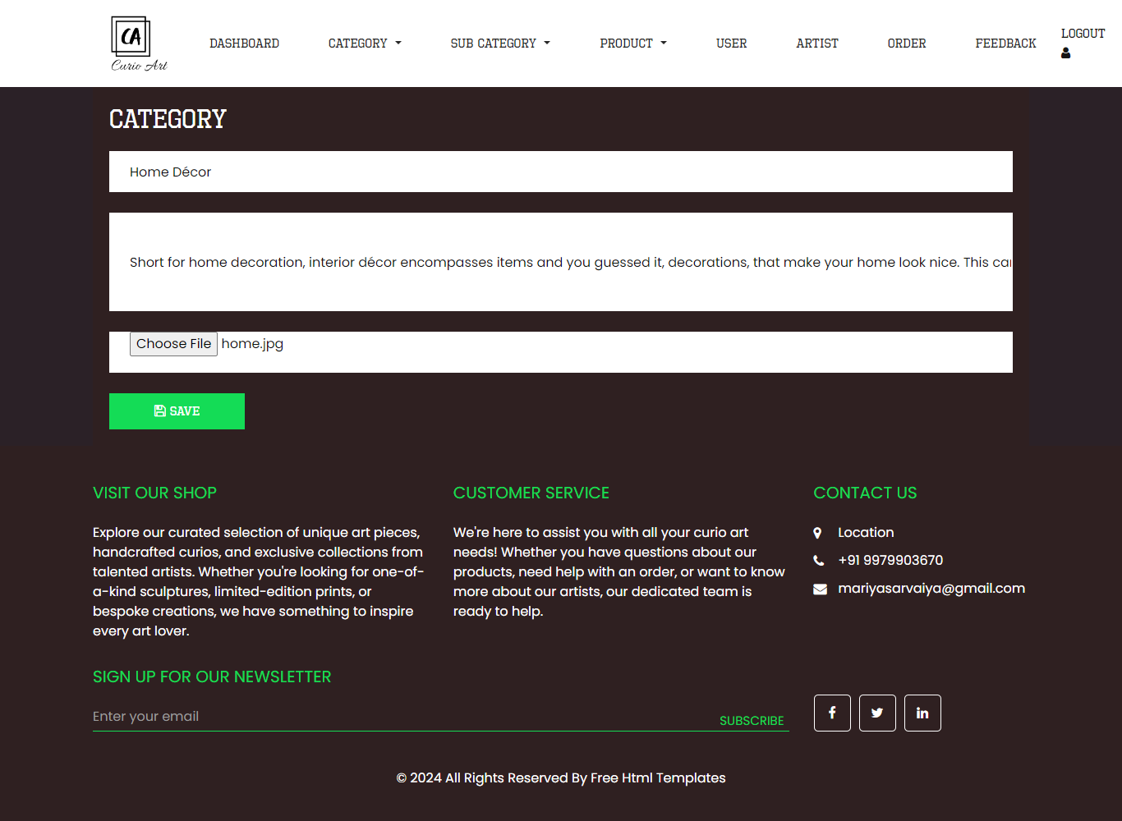
This is a for edit category page.

6)Add Sub Category
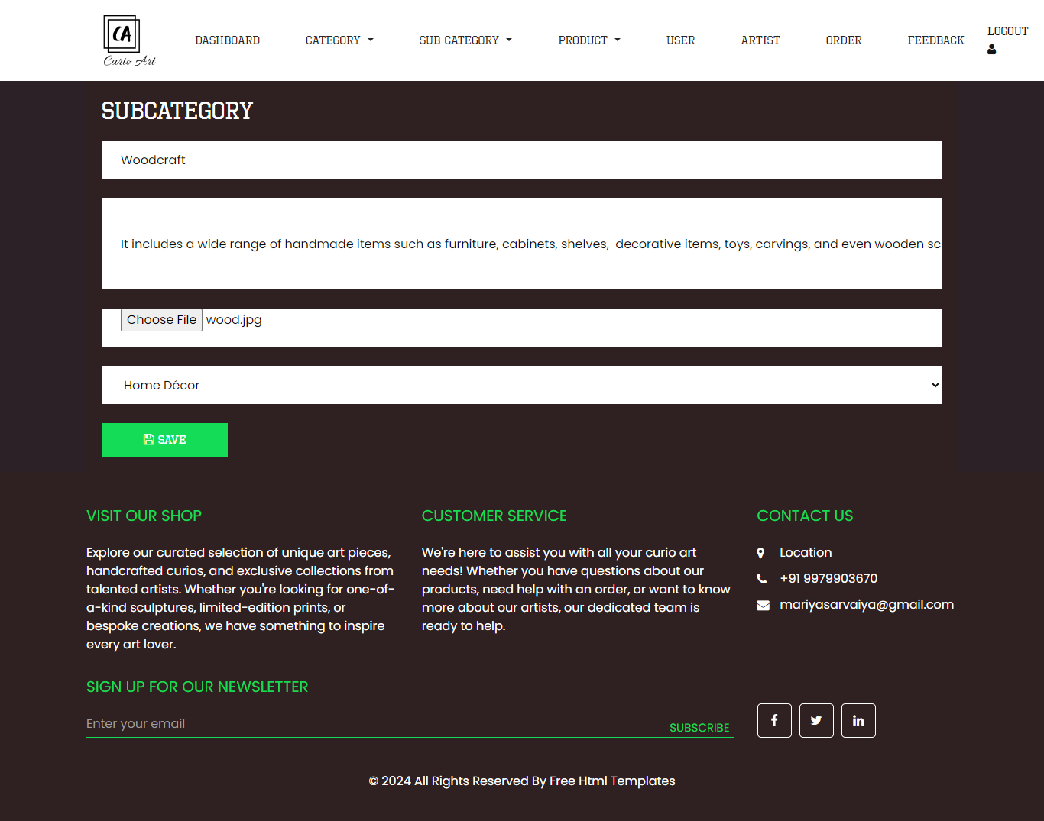
This is a for add subcategory page.

7)View Sub Category
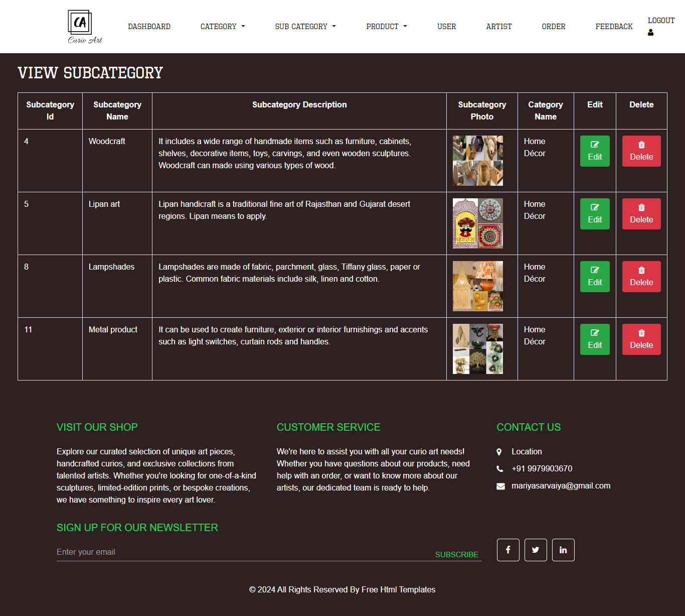
This is a for view subcategory page.

8)Edit Sub Category
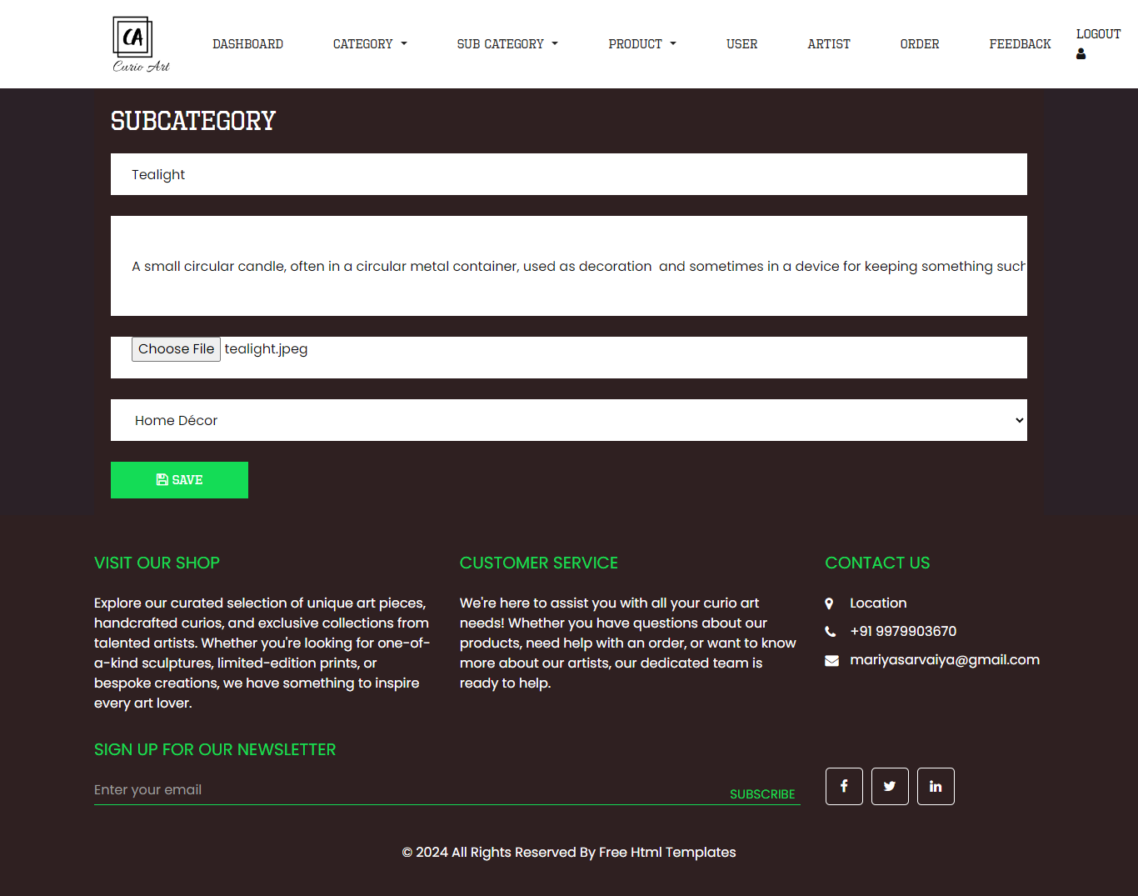
This is a for edit subcategory page.

9)Add Product
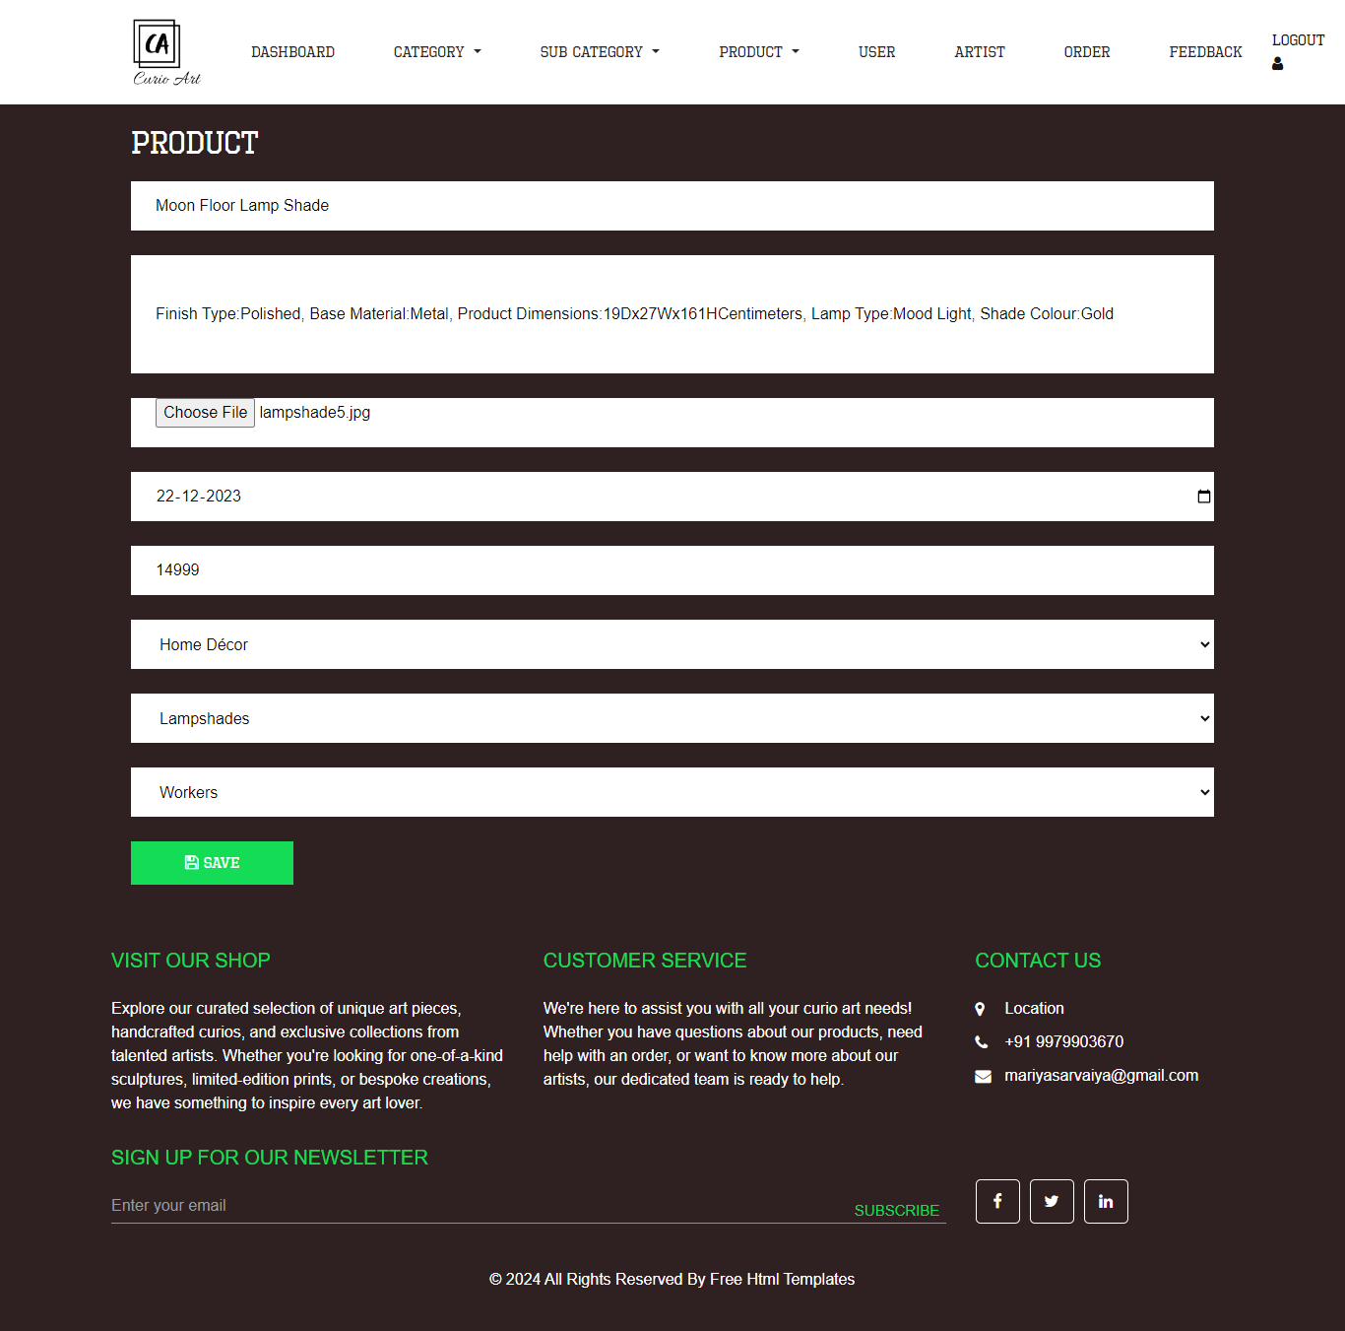
This is a for add product page.

10)View Product
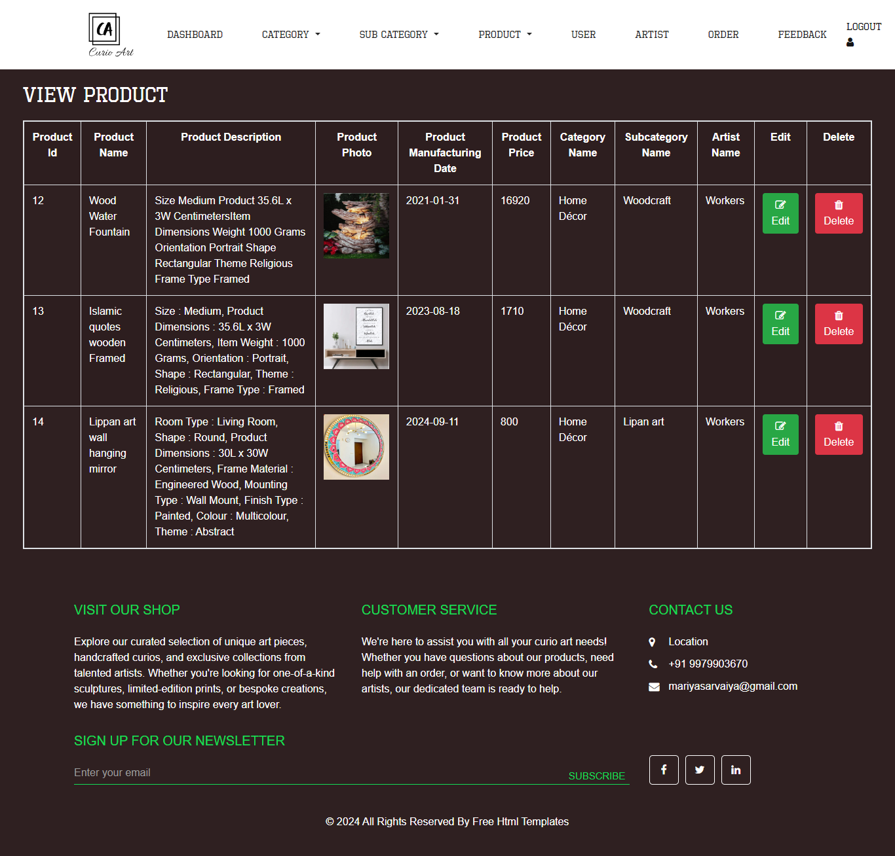
This is a for view product page.

11)Edit Product
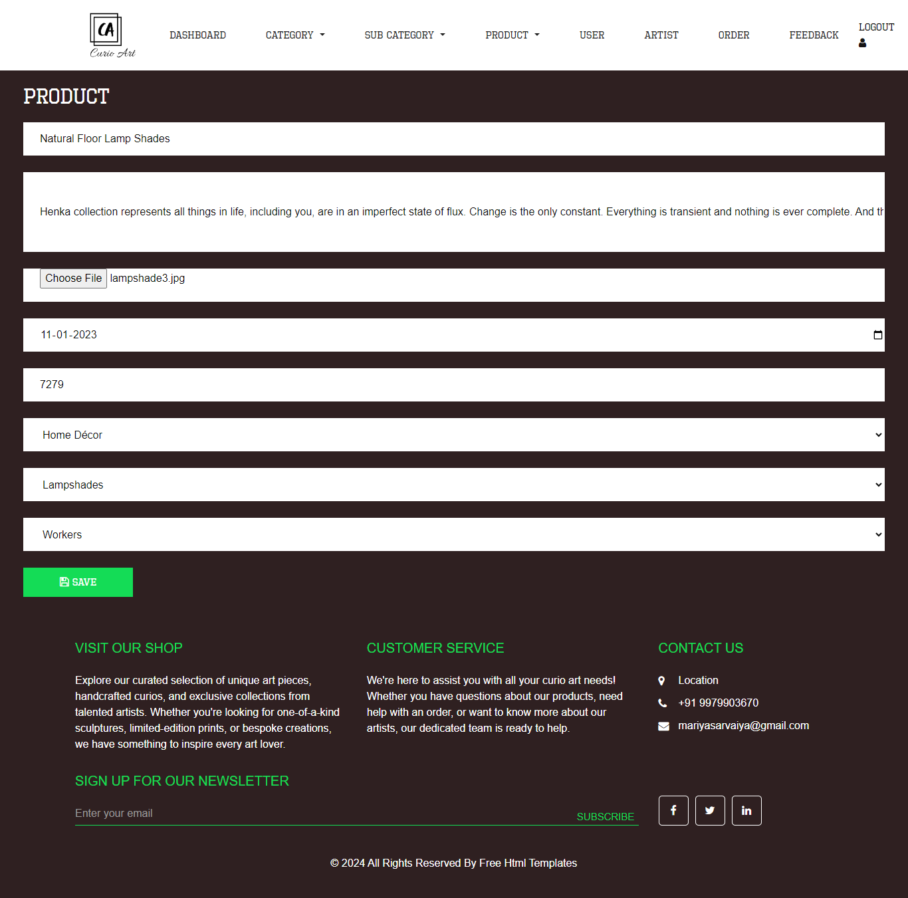
This is a for edit product page.

12)View User
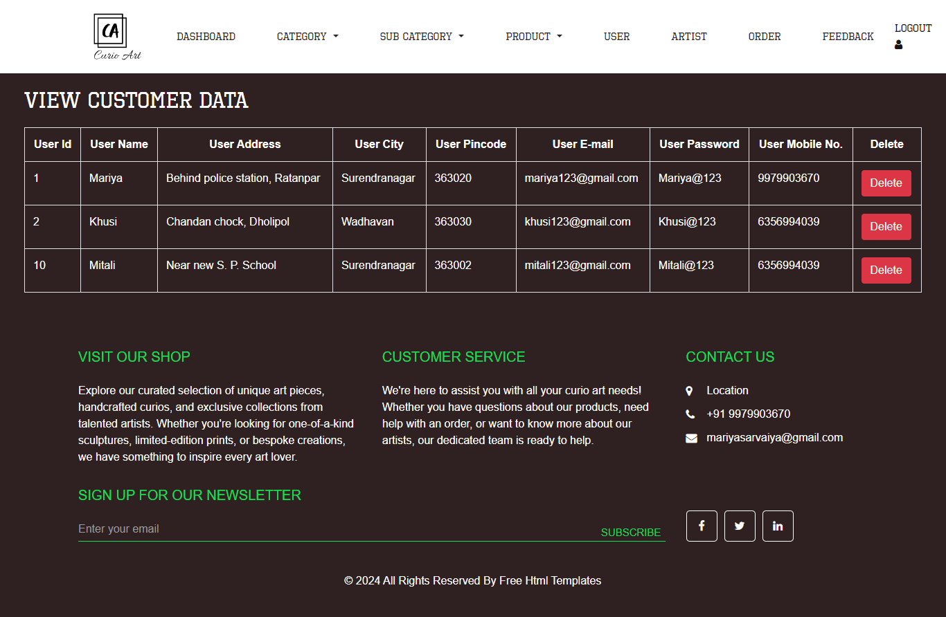
This is a for view user page.

13)View Artist
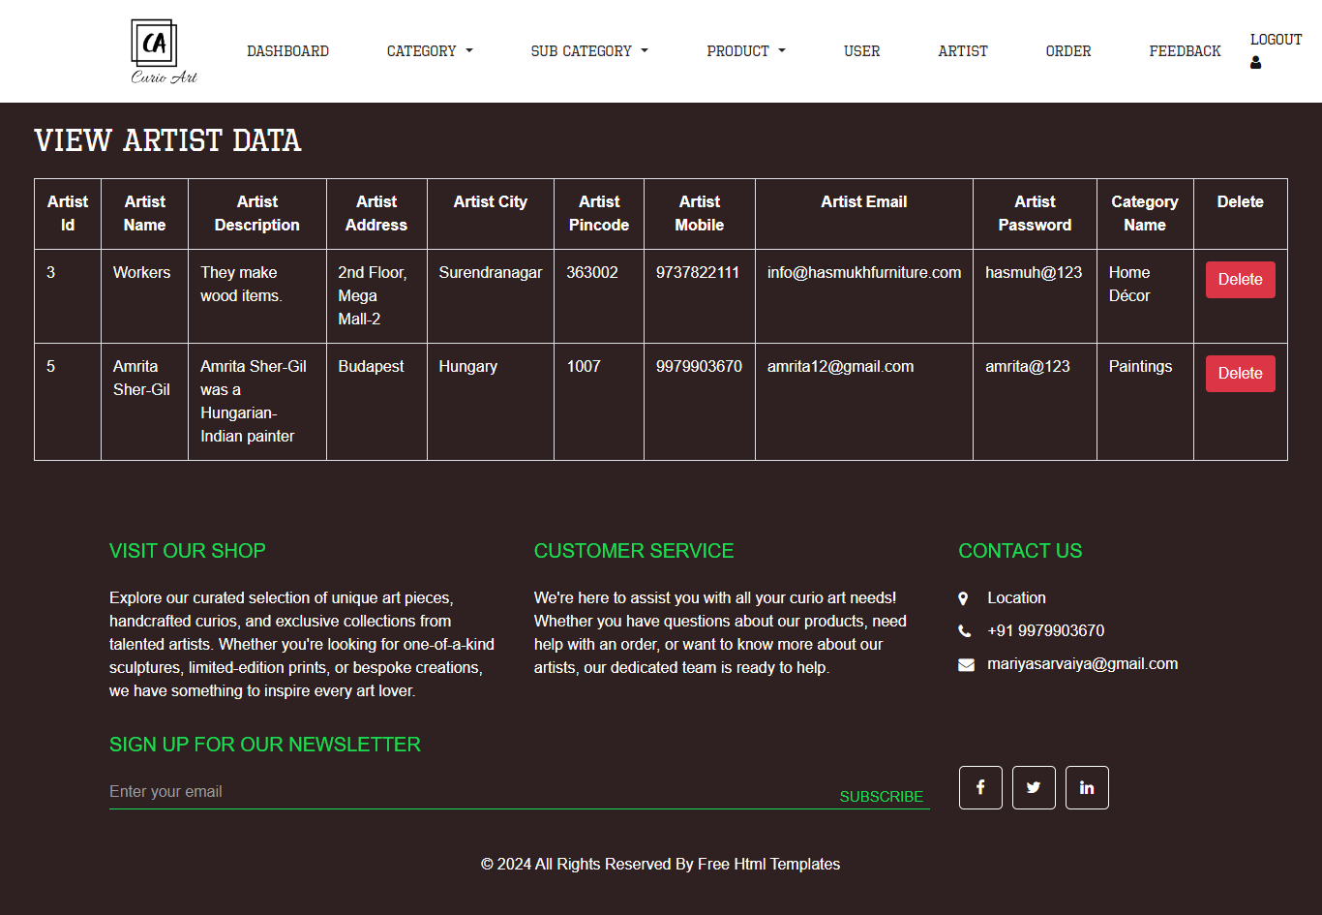
This is a for view artist.

14)View Order
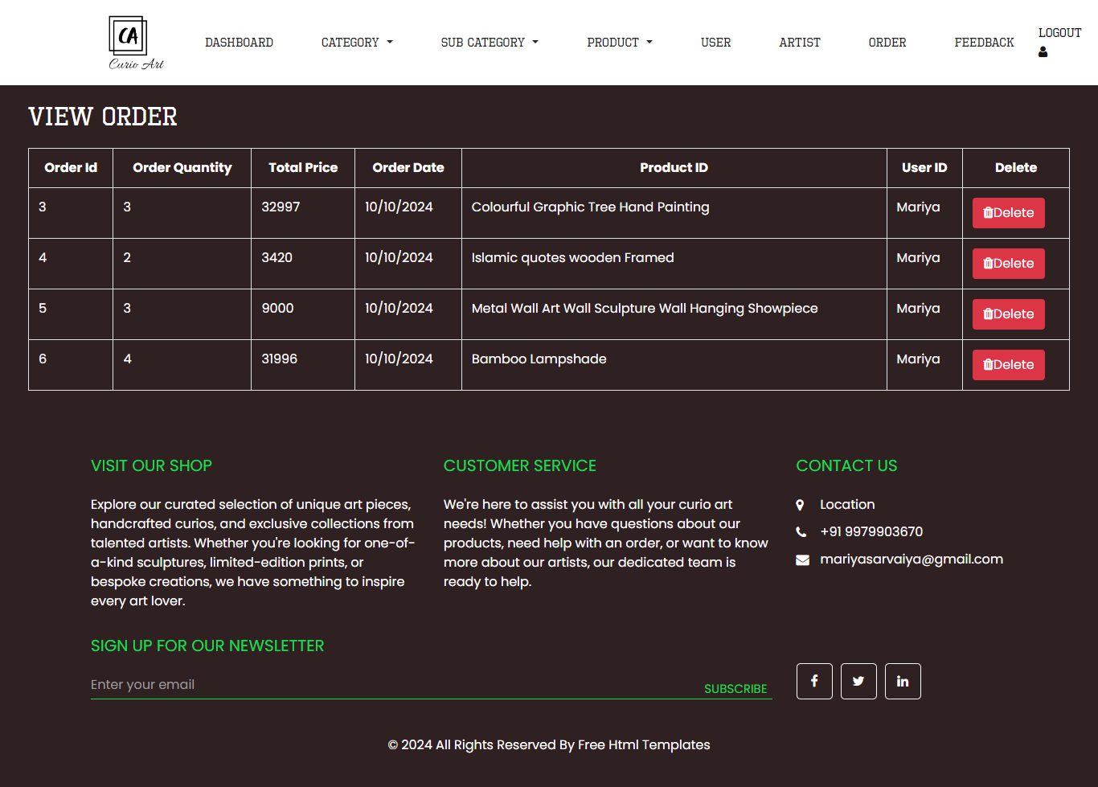
This is a for view order.

15)View Feedback
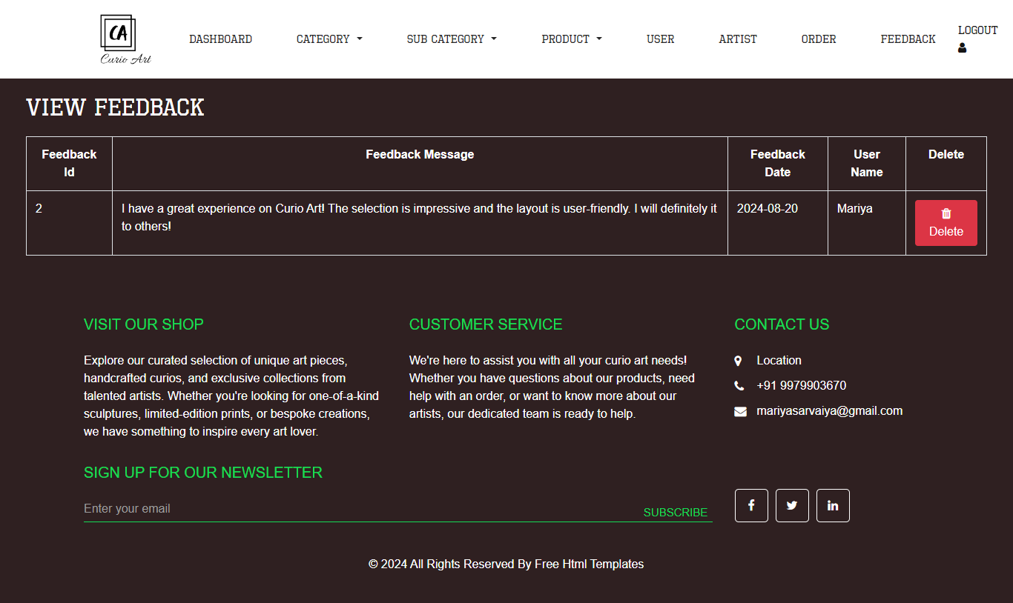
This is for admin side view feedback.

REGISTATION USER
1)Registration Login
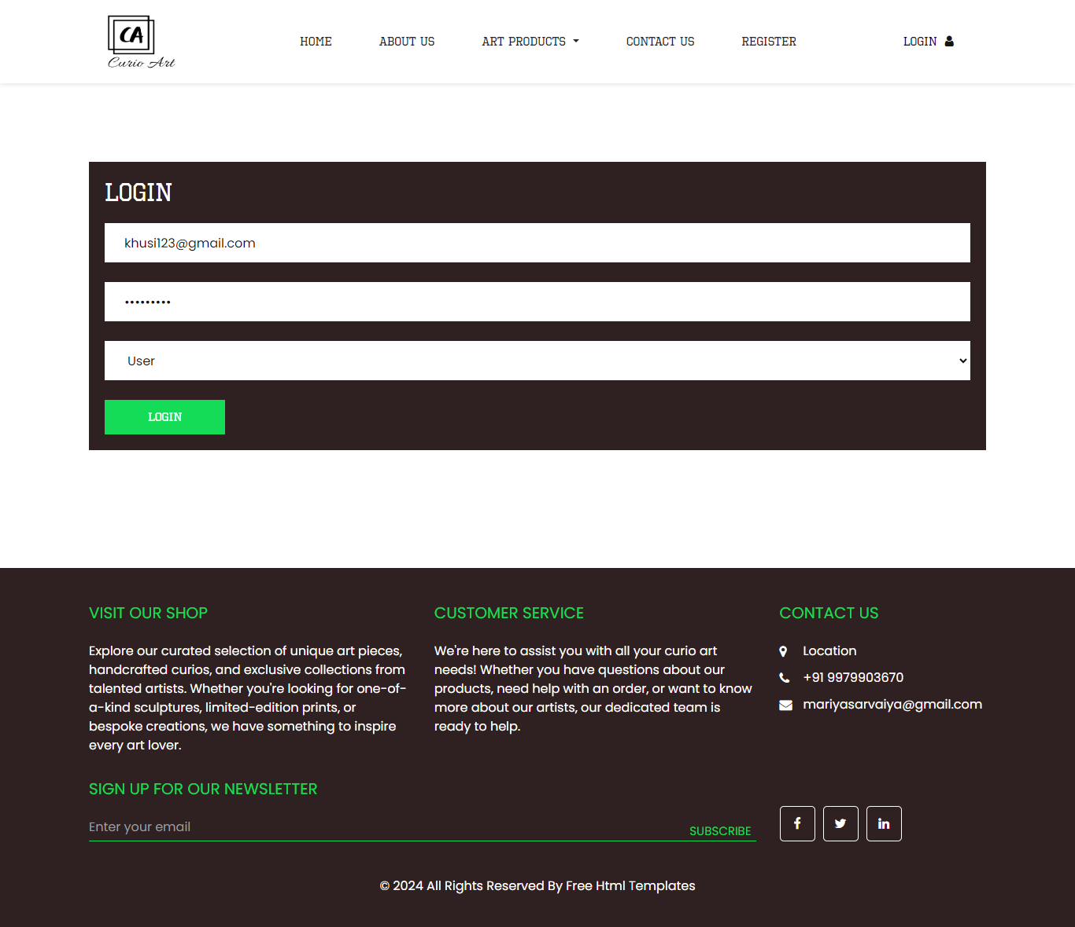
This is a register login page.

2)Registration Home
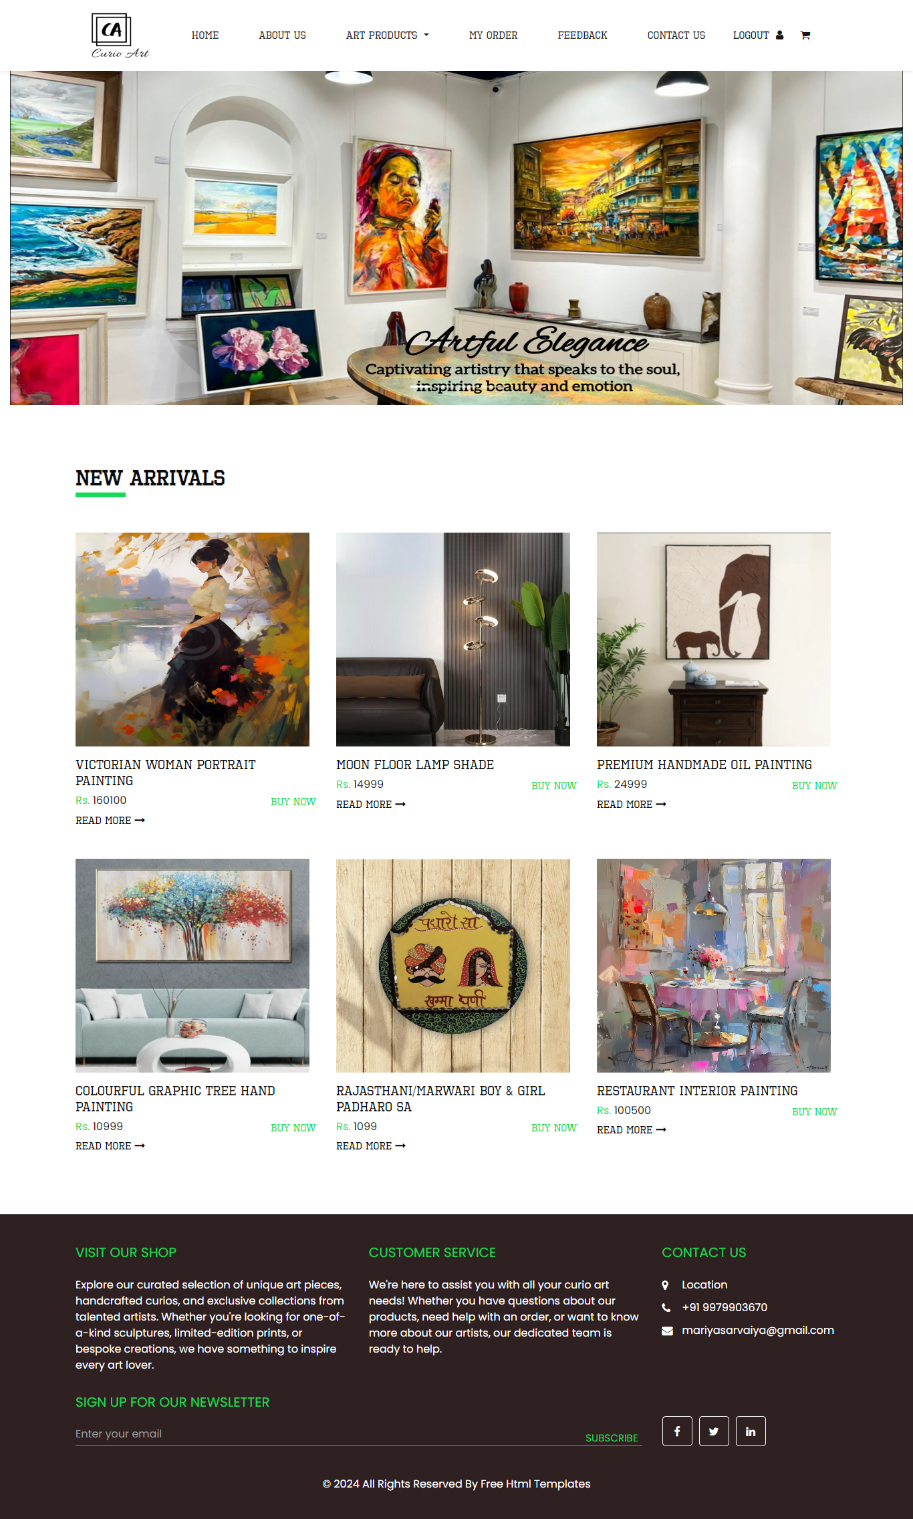
This is a registration side home.
3)About Us
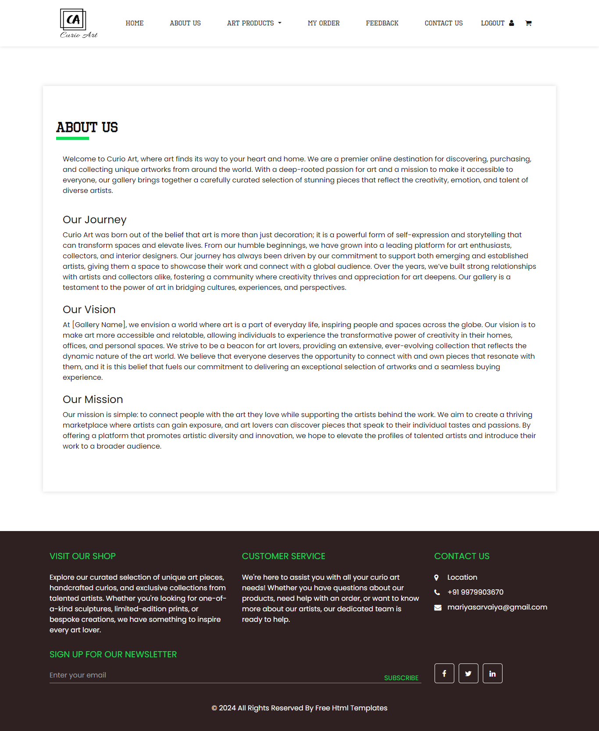
This page is a show detail of our shop.
4)View Category
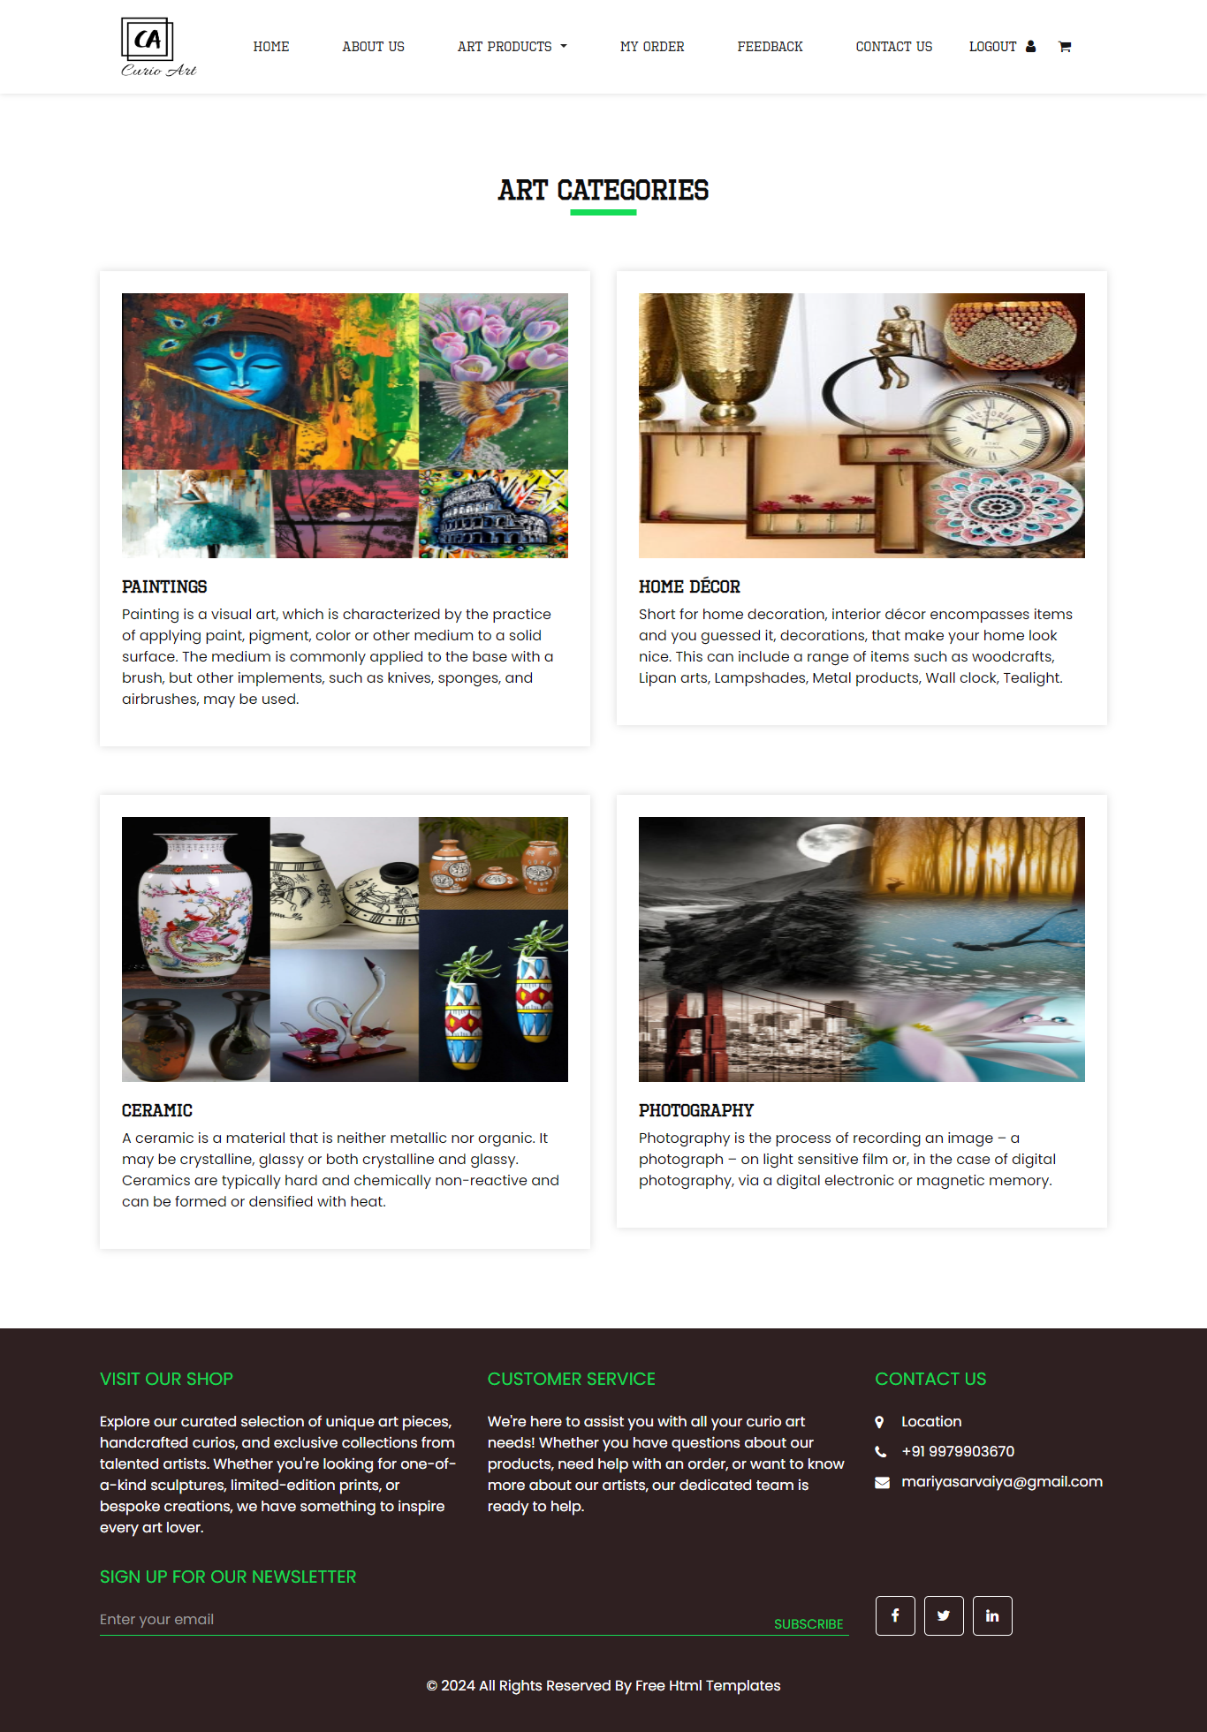
This is a registration side view category.
5)View Sub Category
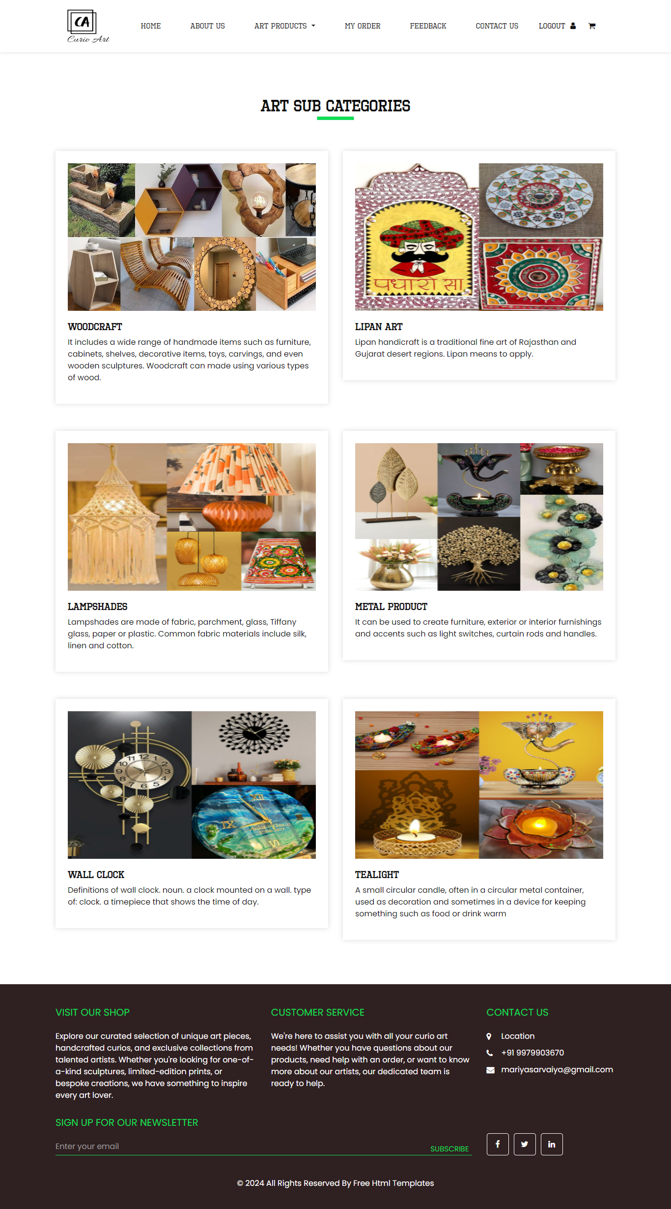
This is a registration side view subcategory.
6)View Product
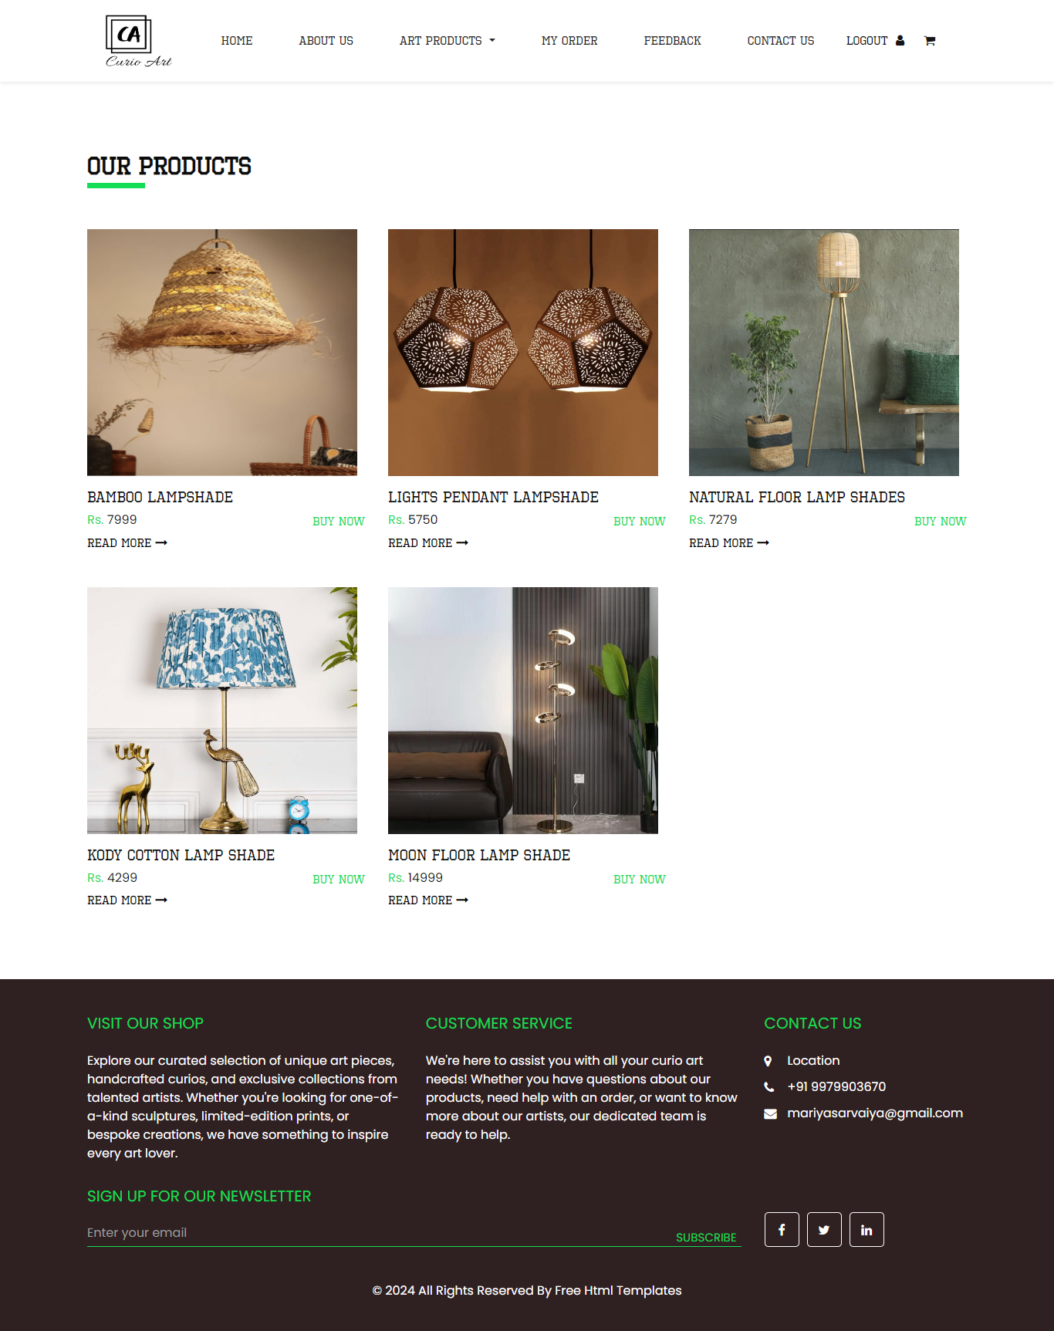
This is a registration side view product.
7)View Product Detail
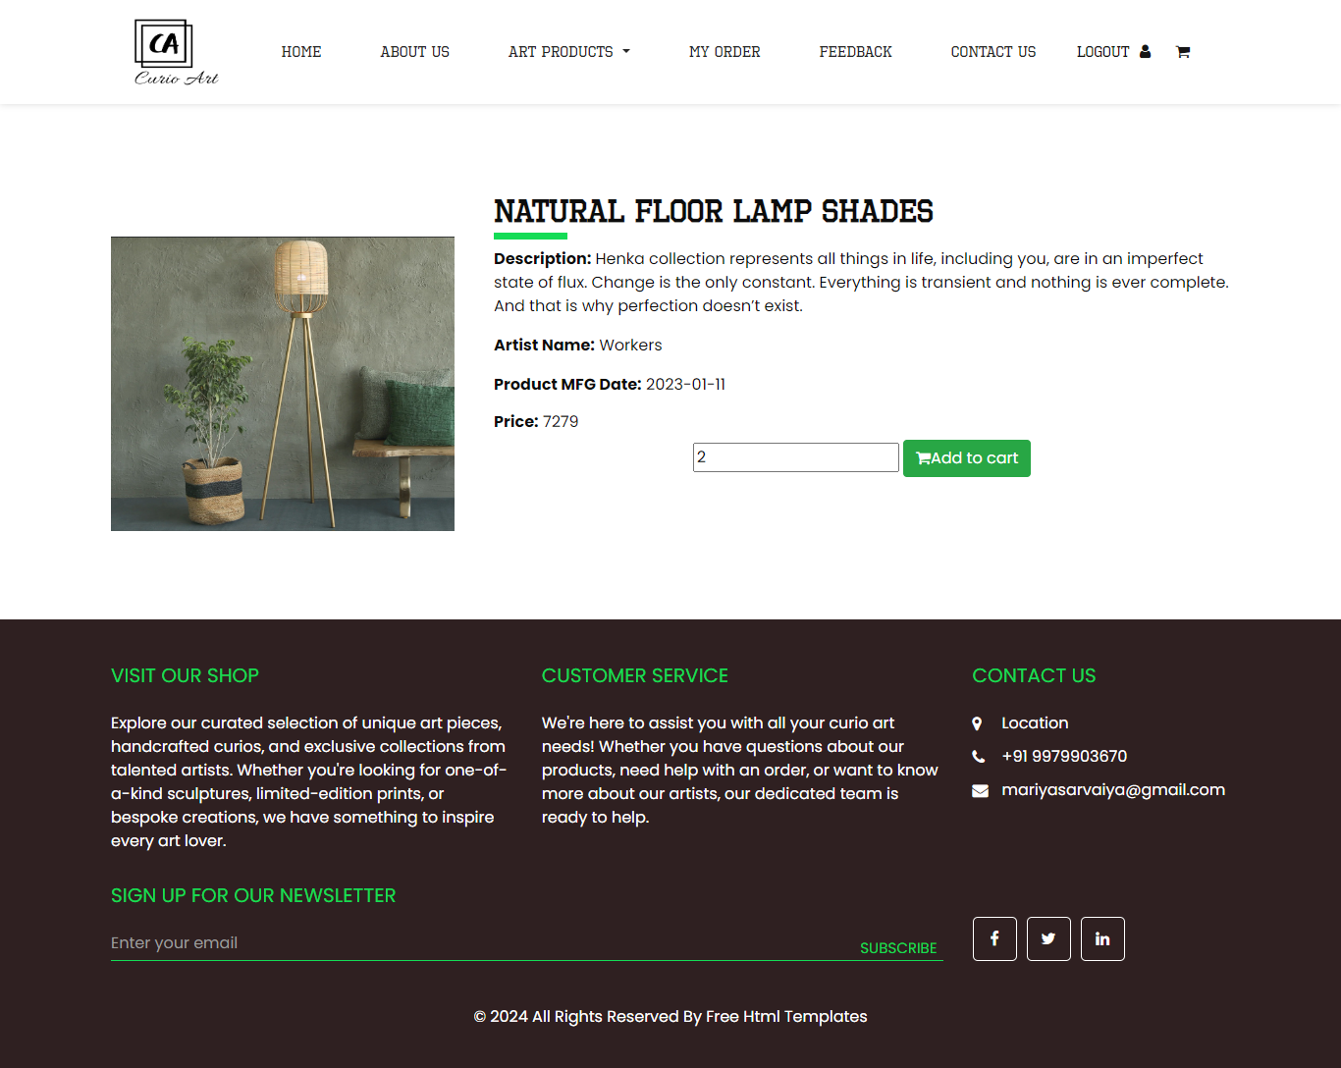
This is a registration side view product detail.

8)View Cart
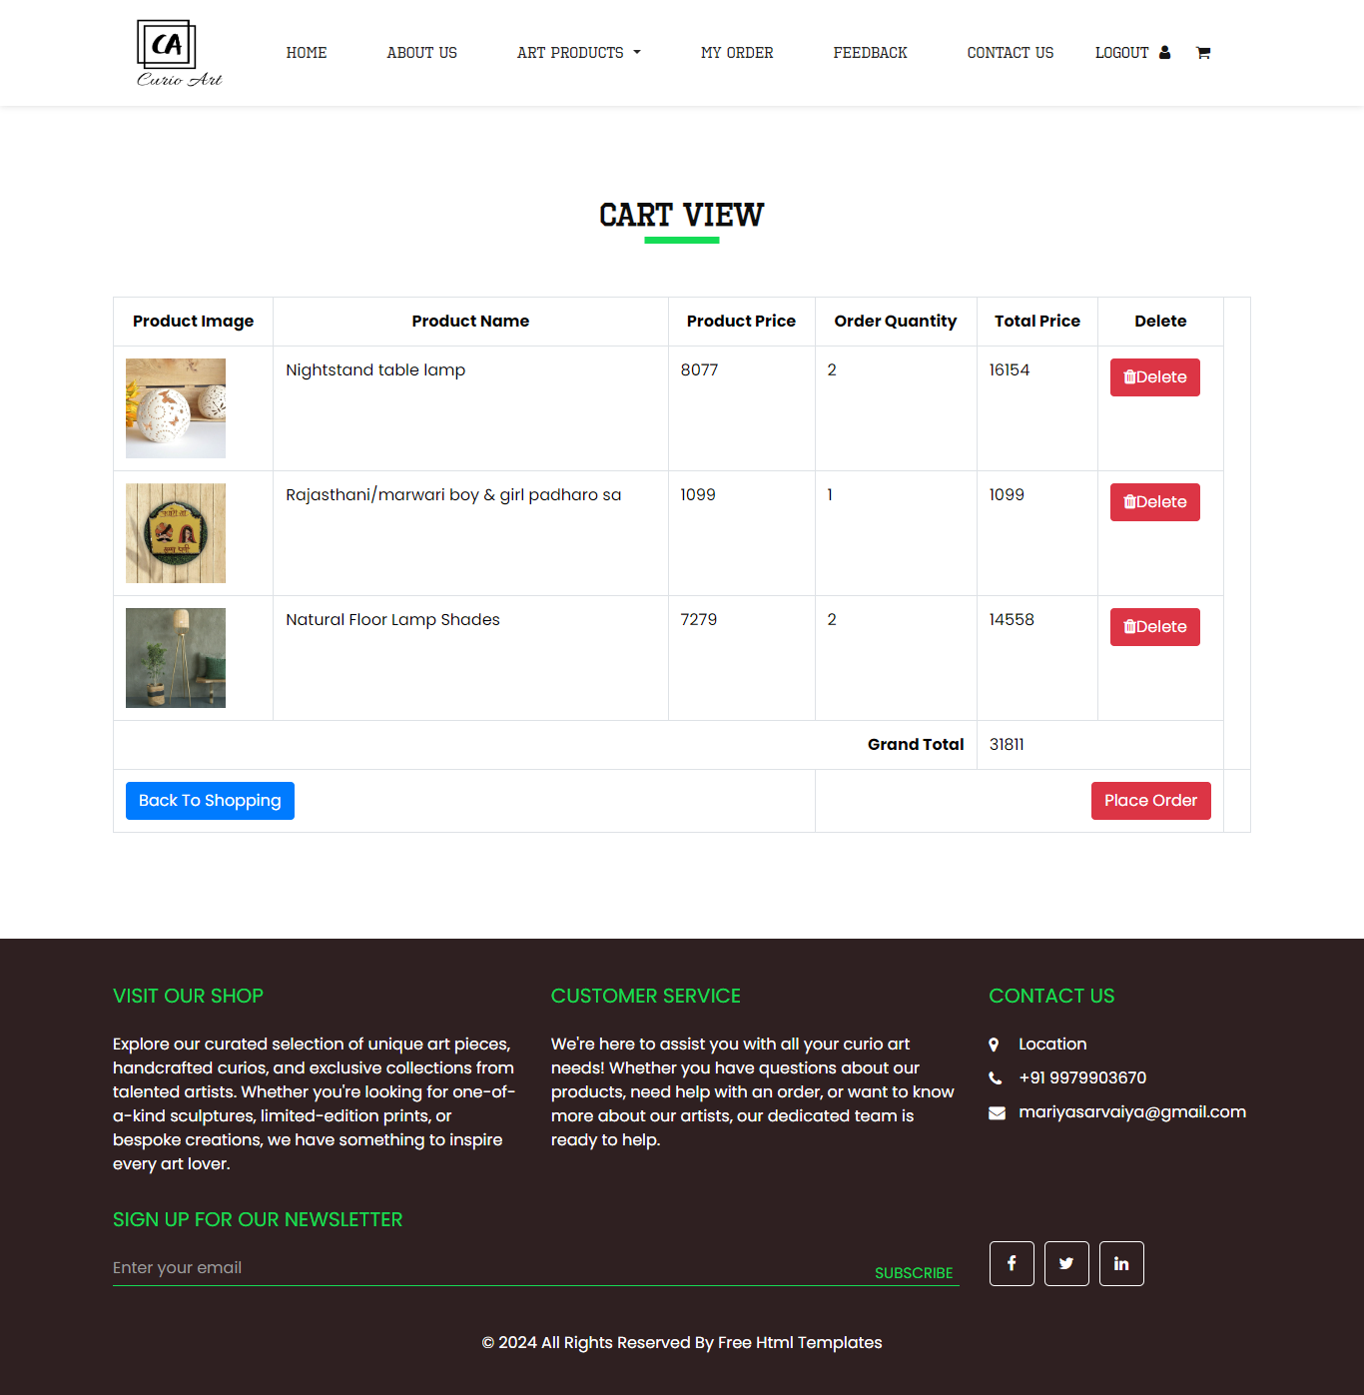
This is a registration side view cart.

8)View Order
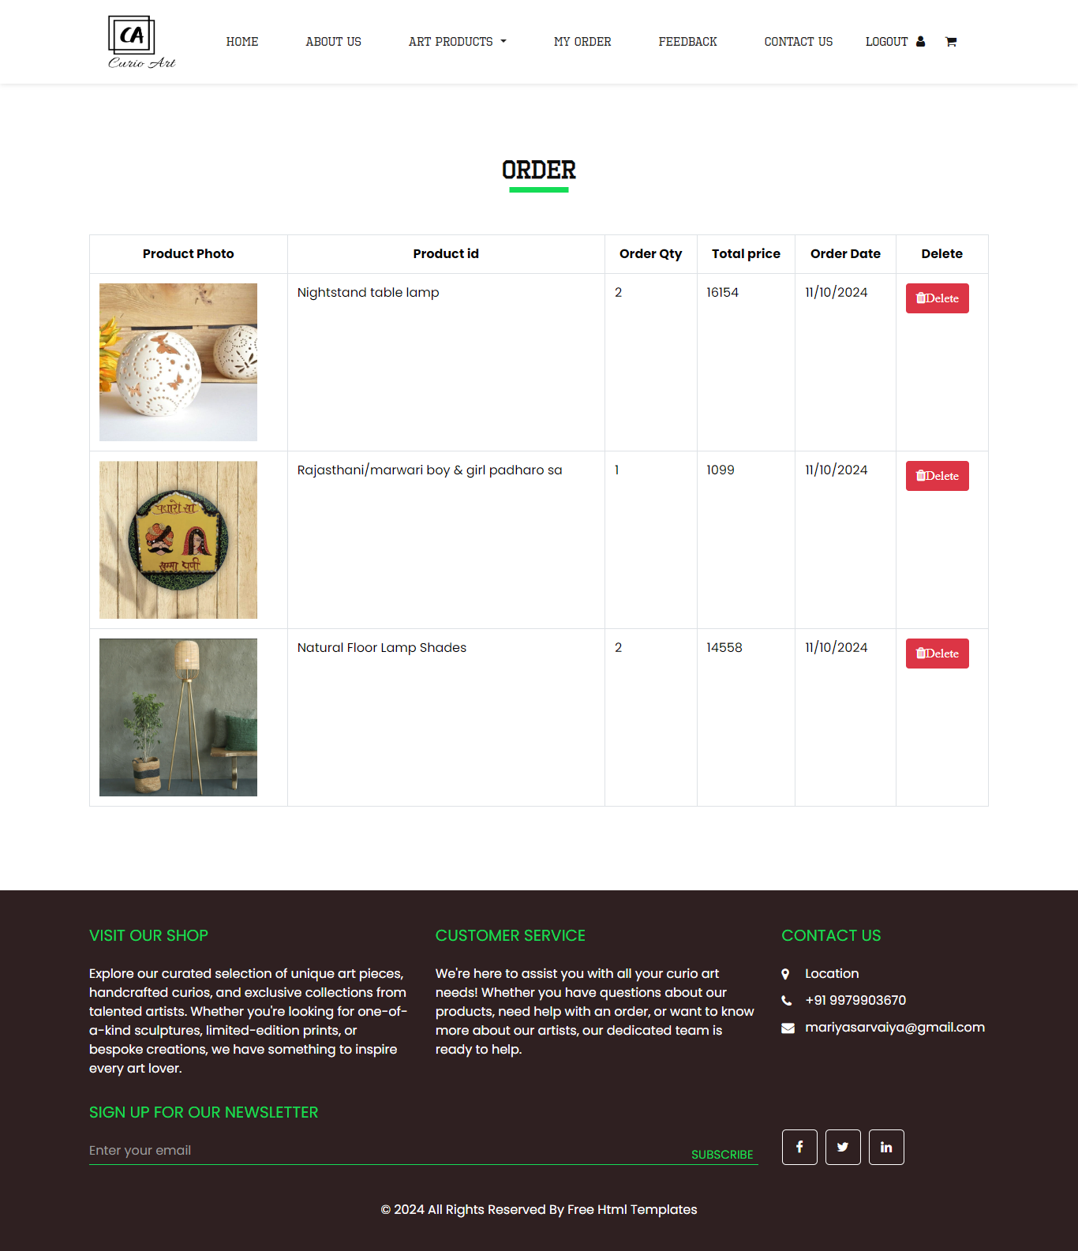
This page is a show the register user order.
9)Contact Us
For any enquiry to contact us.
10)Add Feedback
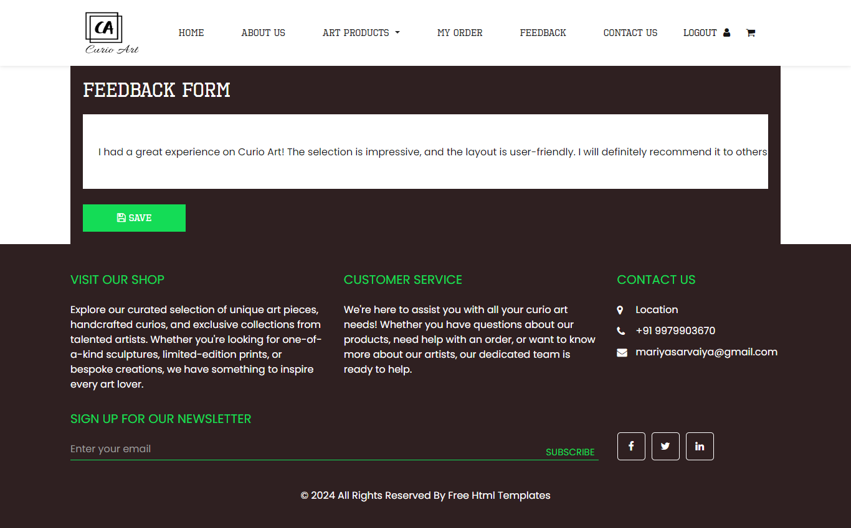
This page is a add the feedback.

